**For Referees Only**

**Perry Charles Horner**

TRAVELLER

Science Fiction Adventure in the Far Future

Special Software 1

Travellers’ Aid Society Access Terminal

**Perry Charles Horner**

*TRAVELLERS’ AID SOCIETY ACCESS TERMINAL*

OPEN SOURCE COMPUTER GAMING SOFTWARE

Version: 2.49

**Science-Fiction Roleplaying in the Traveller® 1 Universe**

**Credits**

|  |  |  |  |  |
| --- | --- | --- | --- | --- |
| Design | Perry C. Horner | | | |
| Layout | Perry C. Horner | | | |
| Computer Source Code | | | Perry C. Horner and others | |
| Source Data Files | | Canon and non-Canon | | |
| Text | | | | Perry C. Horner |
| Date | | | | March, 2016 |
| Computer art images in the manual rendered by Perry Horner (Bryce 7.1, Daz Studio 4.8, Carrara 8.5, Hexegon 2.5, LuxRender 1.4), Art in the TAS application designed and rendered by Perry Horner | | | | |

**Specific Source Code**

*Navigation Library* - Some portions of the sector-subsector generation is based on the code for the Unix program xSSV. The following is the owner information on the specific code. Copyright 1990 by Mark F. Cook ([markc@peak.org](mailto:markc@peak.org) ) and Hewlett-Packard, Interface Technology Operation Modified 6/1990 by Dan Corrin ([dan@engrg.uwo.ca](mailto:dan@engrg.uwo.ca) ), Modified 7/1993 by Jonathan Sari ([surge@cqs.washington.edu](mailto:surge@cqs.washington.edu) ), planet mapping code (planet.c) by Torben AE. Mogensen ([torbenm@diku.dk](mailto:torbenm@diku.dk) ) and adapted for this application by Perry Horner ([perry1@liberated-technologies.com](mailto:perry1@liberated-technologies.com)), system decoding code (fullupp.c) by Paul J. Netherwood ([P.J.Netherwood@uk.ac.kingston](mailto:P.J.Netherwood@uk.ac.kingston) ) and adapted for this application by Perry Horner, with the additional bulk of the code by Perry Horner.

*Main Menu -* Code by Perry Horner ([perry1@liberated-technologies.com](mailto:perry1@liberated-technologies.com) )

*Login Screen -* Code by Perry Horner ([perry1@liberated-technologies.com](mailto:perry1@liberated-technologies.com) )

*News Service -* Code by Perry Horner ([perry1@liberated-technologies.com](mailto:perry1@liberated-technologies.com) )

*Library Data -* Code by Perry Horner ([perry1@liberated-technologies.com](mailto:perry1@liberated-technologies.com) )

*Account Services -* Code by Perry Horner ([perry1@liberated-technologies.com](mailto:perry1@liberated-technologies.com) )

*Communications -* Code by Perry Horner ([perry1@liberated-technologies.com](mailto:perry1@liberated-technologies.com) )

*Classifieds -* Code by Perry Horner ([perry1@liberated-technologies.com](mailto:perry1@liberated-technologies.com) )

**Navigation and Library Data**

Core Library - Joseph Heck ([ccjoe@showme.missouri.edu](mailto:ccjoe@showme.missouri.edu)) <http://www.missouri.edu/~ccjoe/traveller/library_data.html>

TNE Library – Pete Gray ([ferrosmith@yahoo.com](mailto:ferrosmith@yahoo.com) )

Some sector and lib data was ftp'd from Sunbane server back in the days.

Some sector data from http://maps.grandsurvey.com

Gushemege Sector by Joe Fugate, David Burden(david@innocom.demon.co.uk) and Leighton Piper.

Source: Core [http://members.nova.org/~sol/core/]

Additional rework done to consolidate trade routes, subsector names, and star inclusions by Perry Horner

Foreven Sector – GypsyComet, Dylan Lee and BeRKA (zho.berka.com/data/foreven)

Afawahisa - BeRKA http://zho.berka.com/

Arzul Sector - The star positions and the sector name are taken from Vilani and Vargr, Digest Group Publications; all other information, unless otherwise noted, is the work of Jeff Zeitlin (jeff.zeitlin@execnet.com).

Canopus - This data was generated by Rupert Boleyn (rboleyn@paradise.net.nz) based on the starmap in DGP's 'Cats 'n Rats'.

Magyar – Sunbane FTP site and Dakin Burdick burdickd@indiana.edu

Crucis Margin - Crucis Margin is copyright 1981 by Judges Guild. The sector was written by Dave Sering, with artwork by Ken Simpson and Ed Perry. Bob Bledsaw (judgesguild@q-com.com) gave permission for this sector to be transcribed into Galactic. The transcription was done by Robin Ludbey (rludbey@ozemail.com.au) August 1998.

Vanguard Reaches - data is by Chuck Kallenbach II <scoundrl@inlink.com>. The text for the Library Data was provided by Mr. Kallenbach.

Zhodane - Original data by William Dover and Clay Bush

Gateway - originally published by Digest Group Publications in _The Megatraveller Journal_, #4. It was apparently for Willian H. Keith's Lords of Thunder Campaign (circa 1120-1123). The sector was designed by Thomas A. Dundee. Jens Maskus (Jens.Maskus@stud.uni-hannover.de) converted the sector to Galactic format in 1997.

Gvurrdon - Original data by Roger Myhre <starwolf@online.no>

Gashikan - Jeff Zeitlin (jeff.zeitlin@mail.execnet.com) contributed on 21-Sept-98. The star positions are taken from the dot map in the Vargr section of _Vilani_and_Vargr_, DGP. Historical information and notes are generally based on the information included in Challenge_ #49, GDW, concerning the Julian Protectorate and the Empires of Gashikan.

Iwahfuah – Credits Created from sectorfile using sec2gal at 09:16 14/8-2001. sec2gal by BeRKA http://zho.berka.com/

Tienspevnekr – Taken from compiled HIWG files. Apparently by James "Farstar" Kundert

Usingou -- data was created by John G. Wood, except for subsectors O and P which were created by James Kundert. Star positions were taken (as closely as possible) from the dot map in Vilani & Vargr, as were allegiances; subsector names come from James Kundert. Data mostly by John Wood (John@elvw.demon.co.uk); see his website at http://www.elvw.demon.co.uk/Traveller/ Subsectors O and P by James Kundert removed Vazia and Tanjchiadda, which are duplicate worlds.

Tuglikki -- http://members.aol.com/dedly/traveller/ref_aids.html

Provence -- David Drazul (dedly@aol.com)

Windhorn Sector -- created by John G. Wood. Star positions were taken (as closely as possible) from the dot map in Vilani & Vargr, as were allegiances; subsector names come from Steve Bonneville's consolidated list generated by john wood. His web page for this is at http://www.elvw.demon.co.uk/Traveller/Sectors/Windhorn.html

Neworld -- Created from sectorfile using sec2gal at 11:58 11/8-2001. sec2gal by BeRKA http://zho.berka.com/

Far Frontiers - Dale Kemper; James Kundert. Ares Magazine, The Traveller Chronicle. Source file from http://www.travellermap.com

The Beyond – additional system library data created by DarkStarr (http://www.darkhstarr.com/ )

Deneb – additional items: X-TEK (http://webspace.webring.com/people/oc/cmdrx/main.htm )

Reaver’s Deep- additional library data [Reaver’s Deep Project by Brett Kruger] (http://www.reaversdeep.com/ )

TAS Journal [JTAS] Games Designer’s Workshop, Steve Jackson Games

Challenge Magazine Games Designer’s Workshop

GDW Traveller modules

Library Data compiled by Hyphen, HIWG Member #250 (http://members.tip.net.au/~davidjw/libdata/libframe.htm )

Reavers' Deep Sector Sourcebook by Paul Sanders - Cargonaut Press 1999

A Pilot's Guide To The Drexilthar Subsector

A Pilot's Guide To The Caledon Subsector

The Travellers' Digest #16

The Travellers' Digest #17

Traveller Chronicle #6

Traveller Chronicle #7

GURPS Traveller: Humaniti

Alien - Solomani & Aslan

The Travellers' Digest #18

Ascent to Anekthor

Into The Deep #1

101 Religions

Supplement 8: Library Data (A-M)

Supplement 11: Library Data (N-Z)

Adventure 12: Secret of the Ancients

The Travellers' Digest #19

Into The Deep #2

Duneraiders

Alien Module 1: Aslan

Imperial Encyclopedia

Far Traveller #2

Far Traveller #1

Merchant Prince

Into The Deep #3

Into The Deep #4

**TAS News Service**

TAS Journal [JTAS] Games Designer’s Workshop, Steve Jackson Games

Challenge Magazine Games Designer’s Workshop

GDW Traveller modules

Galactic jimv@uia.net Jim Vassilakos DOS program

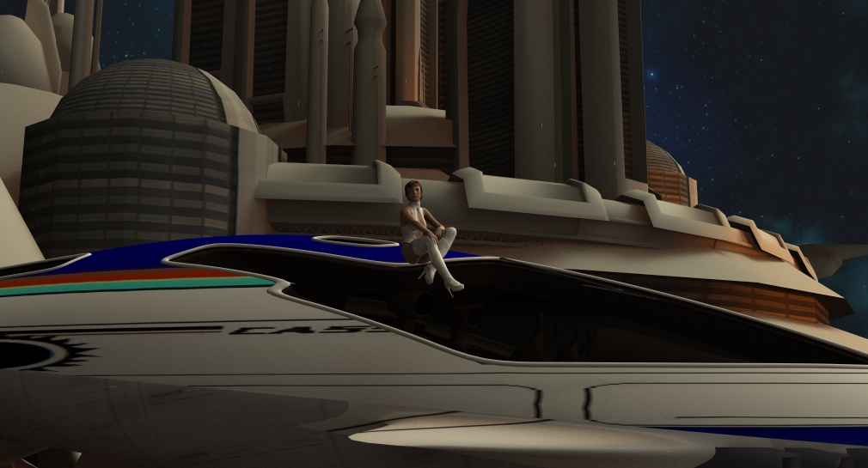

Traveller® is FFE’s registered trademark for its science-fiction roleplaying game system. Traveller, Basic Traveller, Starter Traveller, Classic Traveller, MegaTraveller, Traveller: The New Era, Traveller4, Traveller5, Traveller8, The Spinward Marches, The Edge of the Empire, EPIC, The Galaxiad, and Journal of the Travellers’ Aid Society are trademarks of Far Future Enterprises (FFE) – [www.farfuture.net](http://www.farfuture.net)

Some artwork uses 3d object models created and © by Herminio Nieves and Jay Thurman.

|  |
| --- |
| **Contents** 1 |

Quick Installation and Startup 8

MENU: Account Services 10

Banking 10

Account Information 13

MENU: Classifieds 14

For Sale 15

Missions 15

MENU: Communications 18

Message Alert 19

Read New Message 20

Read Old Message 20

MENU: Library Data 21

SEARCH 21

MENU: Navigation Library 23

Known Space Menu 23

Sector Menu 24

Subsector Menu 24

Sector and Subsector Library Data 25

Planet Map and System Orbits 25

MENU: News Service 28

Administration of the TASAT Application 31

System Troubleshooting 41

Appendix A: Allegiance Codes 42

Appendix B: Mapped Sectors 46

Sector Locations (CLASSIC) 46

Sector Locations (TNE) 51

Sector Locations (Milieu 0) 53

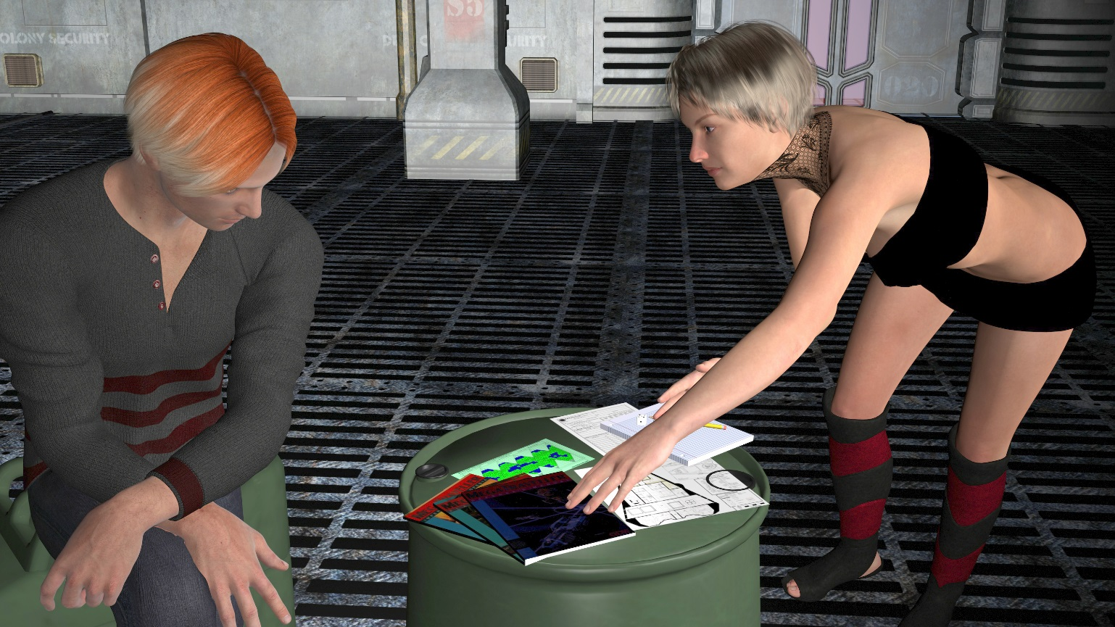

|  |
| --- |
| Introduction |
| I have always wanted a Traveller® computer application that my players could use as they would use their character’s ship computer and TAS terminals in starports. I began with a large outline of what such a program would consist of. The de-facto era I chose to design it around is the Classic/MegaTraveller period during the 4th and 5th Frontier War until around 1115. After looking it over, I realized that it would take me years to write such a program (I started prototyping the program in GW-BASIC back in 1984, then Turbo-C 1989, then Microsoft C 1995, DirectX in 2000, then Visual C++ using SDL in 2001- lots of porting and rewriting code!). Instead, I decided to work on the most needed section first- the Navigation Library. Since this was my very first Windows-based computer program I ever wrote, it has resulted in what may not be considered very pretty or efficient code. But it is working for me and my players. I also wanted the code to be as cross-platform as possible, so I selected the open source SDL 1.2.x library for the graphics layer and ANSI C for the language. I do not have the time to make and distribute other OS versions so I opened up the project/source code for other Traveller® programmers and referees and made sure all was released under the GPL. Thus, the Travellers’ Aid Society Access Terminal was born. I would like to share the work I have done and the master schema. I hope others can add additional modules and modifications to make this program fully functional (tall request, I know.) Even the Navigation Library has still a lot of work to be done. Sectors need to be added for various eras, library data generated, addition of planetoid info, and other program modifications, or a new port to a newer operating system. Please enjoy, and thank you Marc Miller for creating this inspiring game! – *Perry Horner, October 2014* |

*TRAVELLERS’ AID SOCIETY ACCESS TERMINAL*

**Traveller® Usage License**

The Traveller® game in all forms is owned by Far Future Enterprises. Copyright © 1977 – 2015 Far Future Enterprises. Traveller® is a registered trademark of Far Future Enterprises. Far Future permits web sites and fanzines for this game, provided it contains this notice, and that Far Future is notified, and subject to a withdrawal of permission on 90-days notice. The use of this program is for personal, non-commercial use only. Any use of Far Future Enterprise’s copyrighted material or trademarks anywhere in this program and its files should not be viewed as a challenge to those copyrights or trademarks. In addition, any program/ article/ file cannot be republished or distributed without the consent of the author who contributed it.

|  |
| --- |
| Quick Installation and Startup 1 |
|  |

Although the Travellers’ Aid Society Access Terminal (“TASAT”) source code is cross-platform compatible, these instructions are for the Microsoft® Windows® operating system version of the TASAT.

1. Download the TASAT installation file from www.liberated-technologies.com
2. Download and install the Microsoft Visual Studio 2013 Redistributables (also at www.liberated-technologies.com) if needed.(The installer includes this)
3. Run/Execute the installation files above.

**MINIMUM SYSTEM REQUIREMENTS**

TASAT was designed to run in either full screen, or windowed mode. Since the compiler object libraries are modern 32/64-bit based, the minimum requirements are set with this in mind.

* Pentium III or later
* 2GB RAM
* 1024x768 SVGA accelerated graphics card (DirectX capable)
* Microsoft DirectX 7 or later drivers (for Windows OS only)
* SDL 1.2.15 library DLLs or object files (included with installation)
* Mouse and **Keyboard**
* Microsoft Windows Win7/8.x OS
* 200MB hard drive space

**FIRST TIME USERS AND UPGRADES (install to location you have read/write access to [My Documents, etc.)**

When you run the TASAT installation program, it will install all necessary files to use the application. After installation, the TASAT needs two files modified/edited before the application will run.

1. Rename the tas.ini.new file located in the main program directory where you installed the application to tas.ini
2. Rename the accounts.ini.new file located in the /accounts/users sub-directory of the program install directory to accounts.ini

NOTE: Depending on the installation, these files might already be renamed for you

This will set up the default settings for the program. You can edit these files later (see Chapter on *Administration*)

**STARTING THE TASAT APPLICATION**

1. Start the TASAT application [tas.exe] to bring up the Splash Screen followed by the Login Screen [use the tas-WindowMode.bat file for non-full screen]

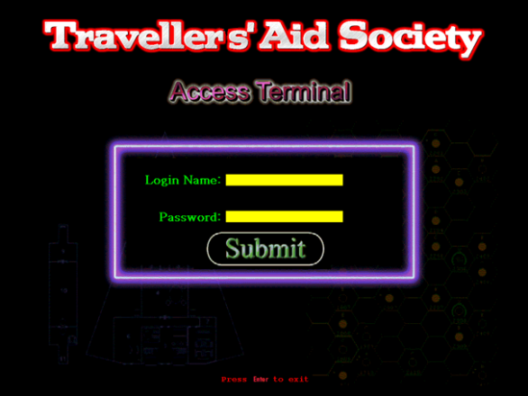

1. Enter a login name and press the **RETURN** key. Then enter a password and press the **RETURN** key. The password will change and state [*Encrypted*]. Mouse Left-Click on the **Submit** button to log in. You can press **RETURN** to exit the application from here also.

*The sample login name* ***bill*** *and password* ***wow*** *will work giving an access level of* ***4****.*

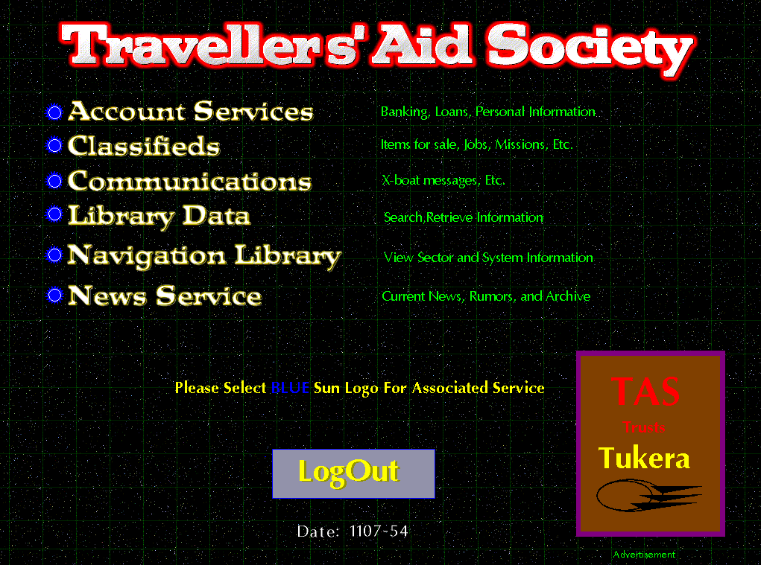

1. From here, select the module you wish to use or ***LogOut*** to exit the menu.
   1. Any menu item represented by a BLUE Imperial Seal 1 means you have access to that portion of the TASAT.
   2. Mouse Left-clicking on the BLUE Imperial Seal 1 will take you to that menu item screen
2. To log out, just left-click on the **LogOut** button, then either:
3. Log in as another user **OR**
4. Press the **ENTER/RETURN** key to exit the application.

*The sample administrator login name* ***admin*** *and password* ***cthulhu*** *will work giving an access level of* ***10****.*

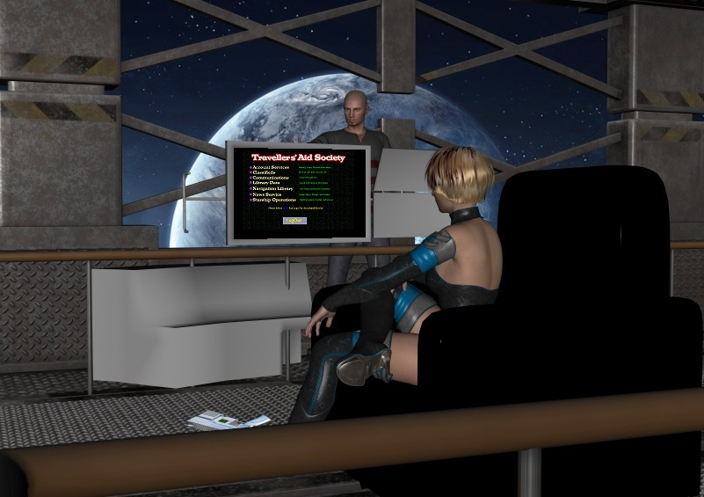

|  |
| --- |
| MENU: Account Services 1 |
|  |

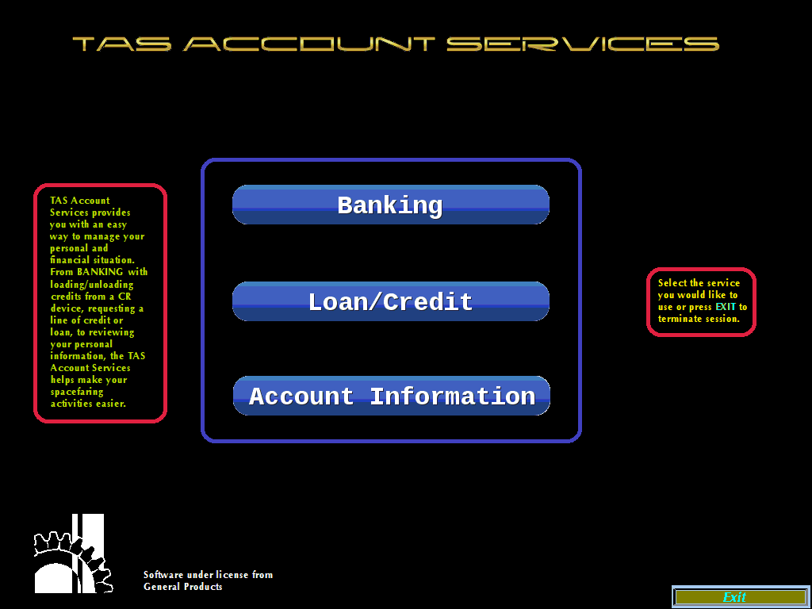Account Services provides a Member banking and loan/credit services. It also provides an overview of the Member’s personal account status within the Society. If one has the appropriate Access Level, then Account Services will be available (selecting the Account Services blue star)

The main items available from the Menu are:

* Banking
* Loan/Credit
* Account Information
* Exit (to main menu)

## **Banking**

The TAS Banking System provides players with a means to deposit and withdraw credits from their account.

Since there are no faster-than-light communications in Traveller other than jump ships, there is no instant data transfer. Bank transfers and credit/debit cards cannot work, or at least not in a useful timeframe, and especially not outside major post routes.

Encrypted cashless money transfer devices (similar to Mondex) are used - if you lose the device, you lose the money, even if it may not be useful to anyone else. This device uses a short-range wireless standard (akin to Bluetooth), which may required a hard-wired connection (plug-in) for high value transfers that require more security. It communicates to the TAS terminal. This is NOT CANON. -*Traveller Wiki [http://wiki.travellerrpg.com/Imperial_Currency ]*

When one selects the Banking menu option, they are presented with the banking menu.

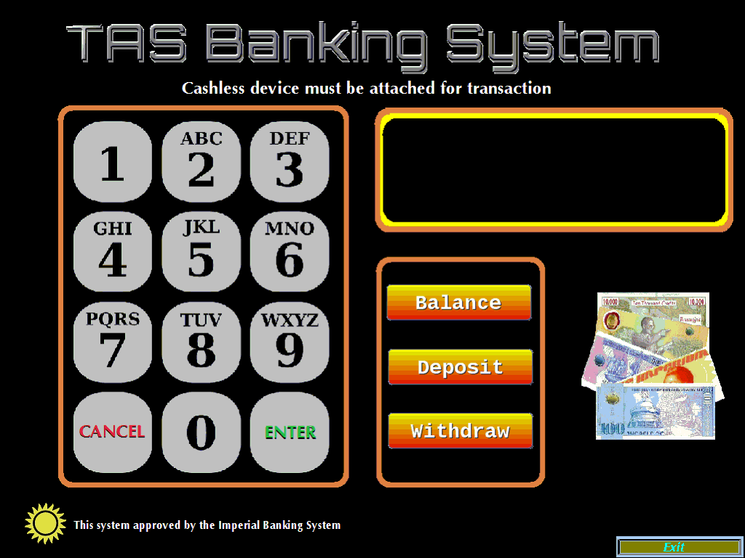

Balance

Selecting the Balance button displays the current amount the account holder has in Cr credits.

This amount is stored in a file located in the /accounts/bank directory. The *filename* is the user’s TAS Member number and .txt

Example: /accounts/bank/5.txt

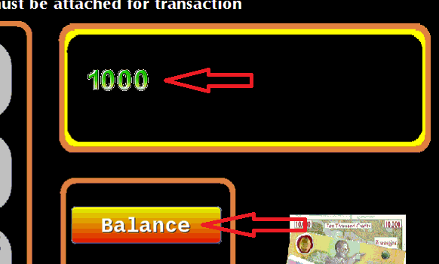

The above user is presented with the amount of 1000 credits when selecting to view account balance.

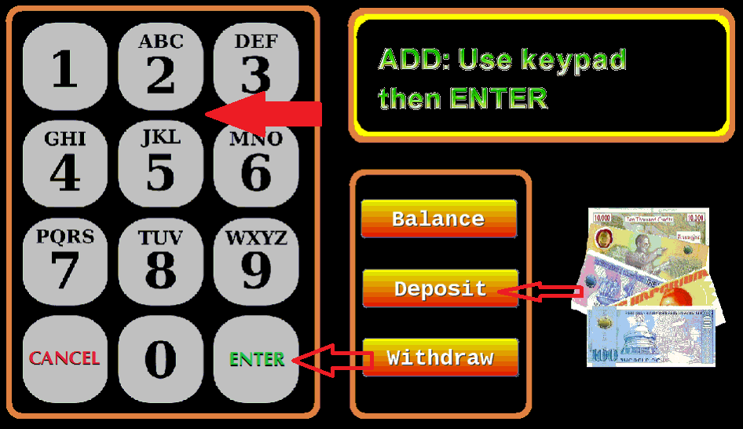

Deposit

To deposit, select the Deposit button, enter the amount to deposit by clicking on the keypad, and click on the ENTER button on the keypad. Selecting CANCEL negates the transaction.

**NOTE**: A bank account can hold up to 2 billion credits.

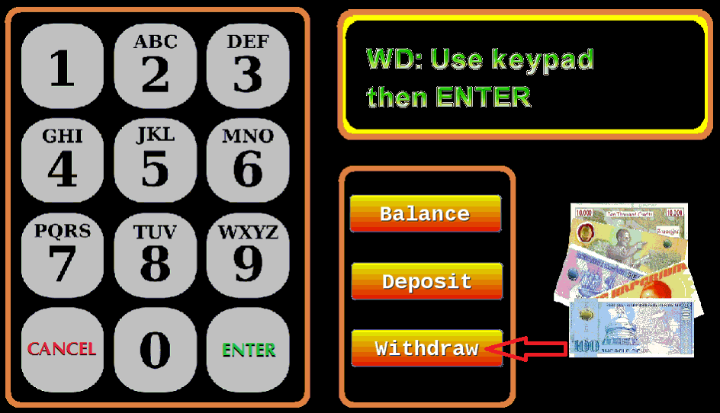

Withdraw

To withdraw, select the Withdraw button, enter the amount to withdraw on the keypad, and click on the ENTER button on the keypad. Selecting CANCEL negates the transaction.

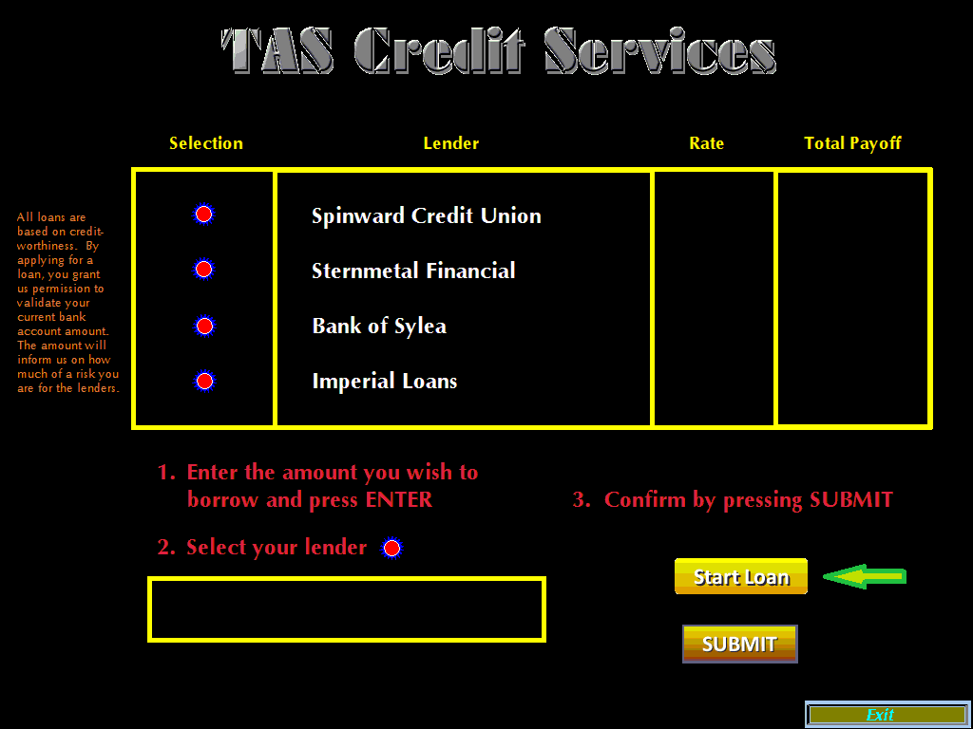

Loan/Credit

The TAS makes it easy to obtain financing from four of the top institutions. To begin a loan query, click on the START LOAN button.

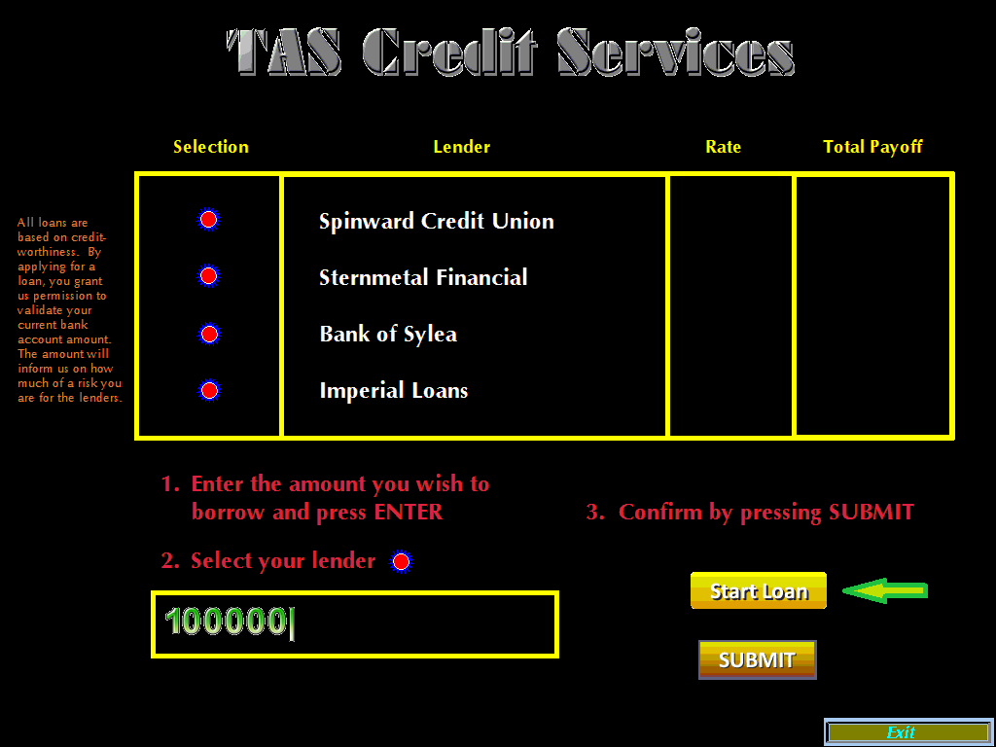

The above example shows the user requesting a loan amount of 100,000 credits.

The TAS Credit Services applies a formula to the loan request for each lender.

|  |  |  |
| --- | --- | --- |
| **Bank balance to loan amount** | **Interest Prime Rate** | **Adj** |
| 80% | 0.2 | x1 |
| 70% | 0.9 | x1 |
| 50% | 1.8 | x1 |
| 30% | 3.3 | x1 |
| 20% | 6.2 | x.1 |
| >10% | 11.1 | x.2 |
| <=10% | 19.1 | x.3 |

*Final Interest Rate = Prime Rate + Adjustment Rate*

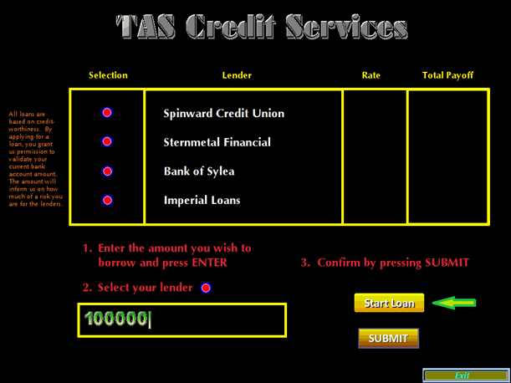

**The interest rate for each lender changes daily**. The amount the user has in their savings/bank account sets the credit worthiness of the user when requesting a loan. The example user has 1000 credits in the bank. Taking a 100,000 credit loan puts the user in the high-risk prime 19.1% bracket.

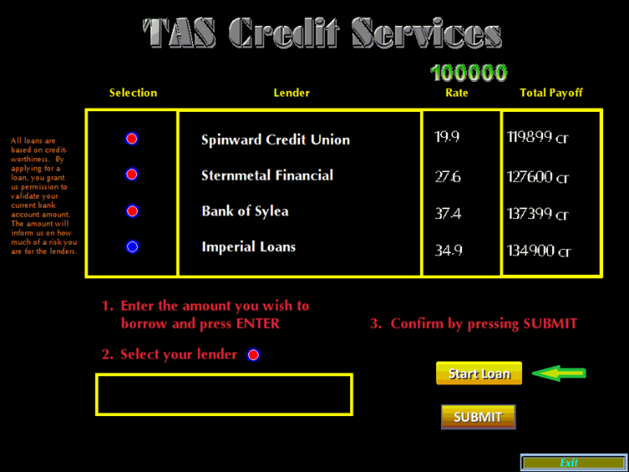

Even though the best rate was from Spinward Credit Union, the user selected Imperial Loans and pressed the SUBMIT button.

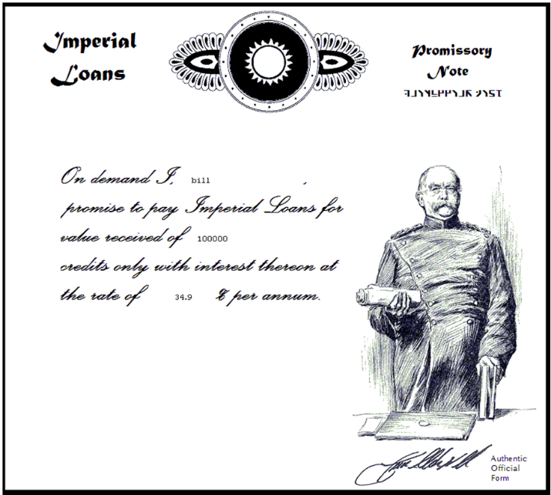

A bitmap image file is written to /saved/account using the filename format of the *username+UPP+_Lendername+loannumber.bmp*

EXAMPLE: */saved/account/bill7A7B77_ImperialLoan21236.bmp*

The Game Master can print the .bmp picture file out for the player/user.

Each lender has their own version of a Promissory Note. Below are representations of the four lenders:

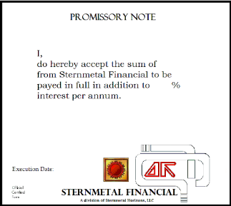

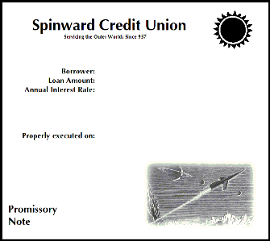

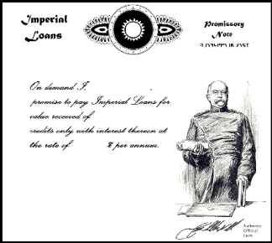

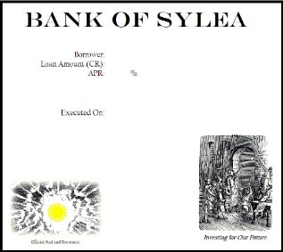

## **Account Information**

The Account Information menu button selection presents the user with an overview screen displaying information specific to the user player character.

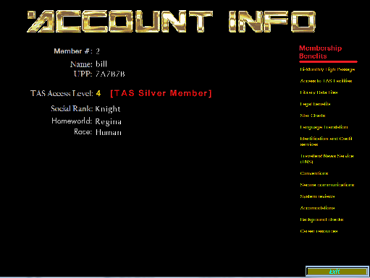

If a player/user wants to know their TAS Access Level standing, the Account Information screen can provide it.

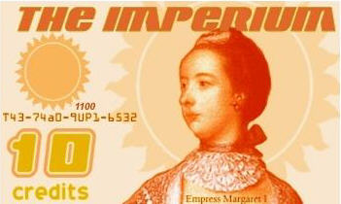

3rd Imperium Polymer Bank Note

|  |
| --- |
| MENU: Classifieds 1 |
|  |

Classifieds provides an outlet for travellers to buy, sell, and find jobs. If one has the appropriate *Access Level*, then Classifieds will be available (see picture below).

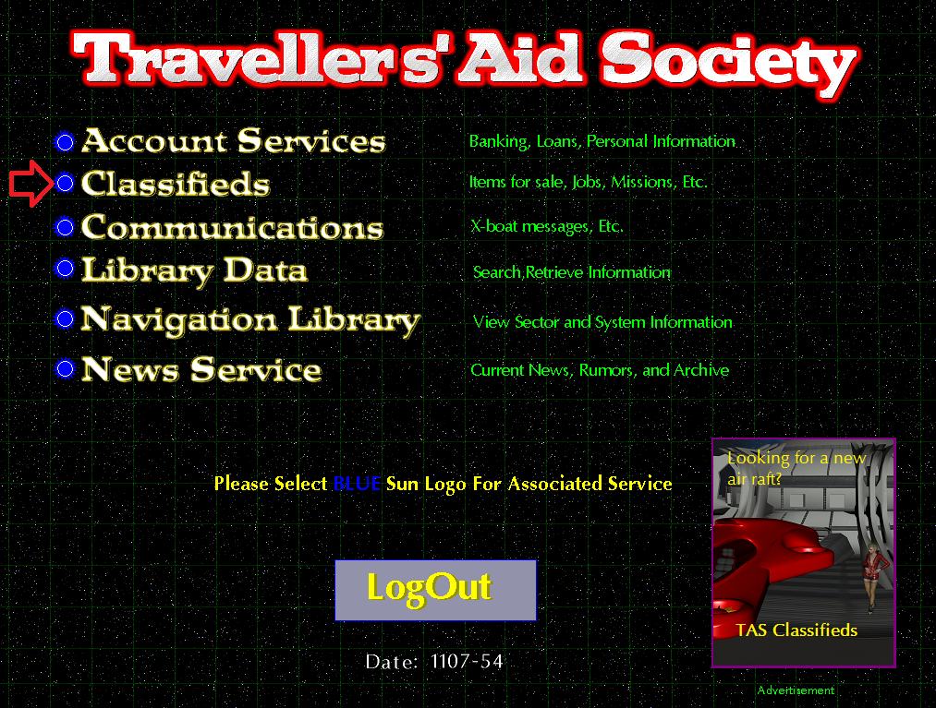

The Classifieds Main Menu presents three categories:

* For Sale- Deals of the day for sale
* For Hire- Jobs that are available to apply for
* Missions- Mercenary Tickets

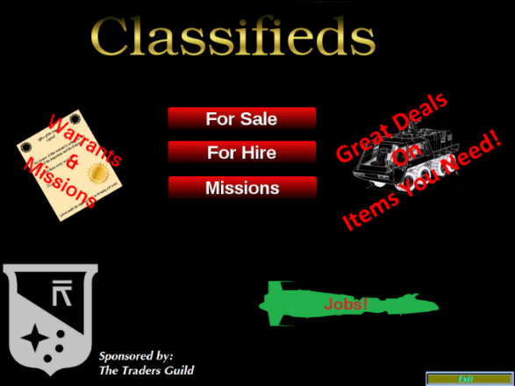

## **For Sale**

The items available in the For Sale menu are deals of the day. This means they are all that are available until the date has changed or the TAS application restarts. The items available are broken into three categories- Spacecraft, Vehicles, and Items.

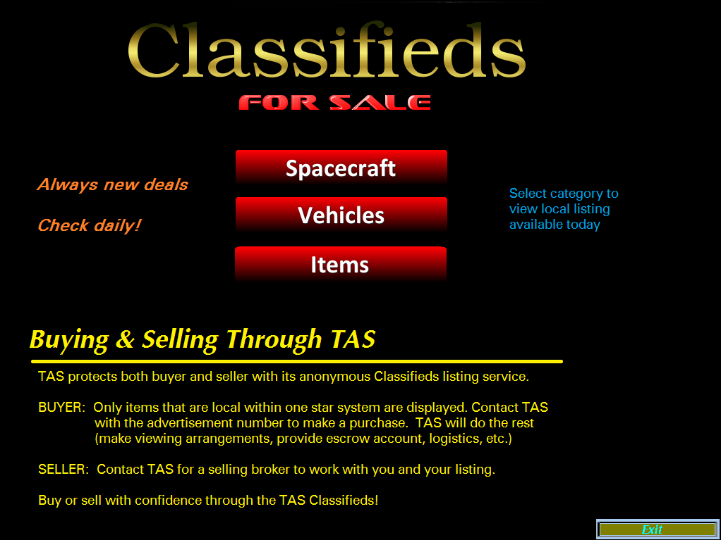

By selecting one of the categories, an advertisement for the “Daily Deal” is presented. The player would let the Referee know if they wish to purchase an item.

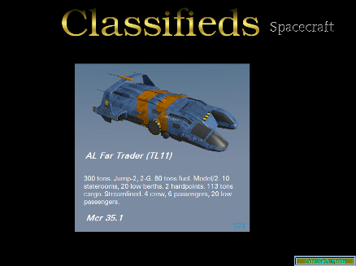

Example:

Spacecraft

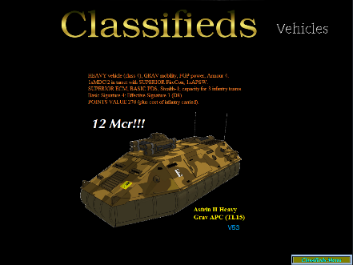

Example:

Vehicles

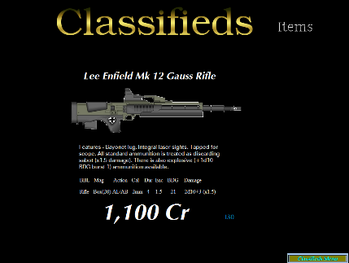

Example:

Items

The included examples all have a code on each picture. The player could send an X-Boat message to TAS referencing the picture ID to inform the Referee of interest for purchase.

## **Missions**

The Missions Menu is only available to those with the appropriate Access Level. If a player has the minimum access level, then they are presented with a Mercenary Ticket review screen:

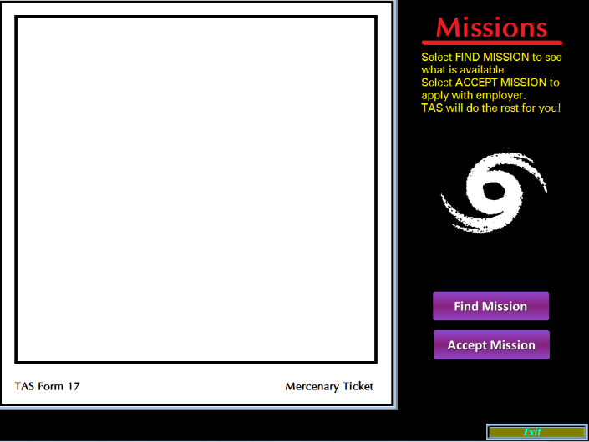

By selecting the **FIND MISSION** button, tickets that are available will display on *TAS Form 17*. One can cycle through the available missions by pressing the **FIND MISSION** button. If more than one ticket is available, continue to press the **FIND MISSION** button to see them.

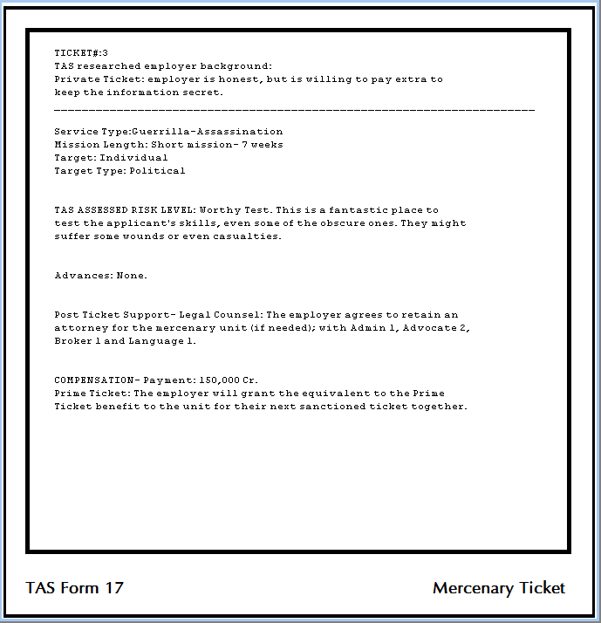

If one finds a Ticket that they want to interview for, then they would press the **ACCEPT MISSION** button. A copy of the ticket will be saved in the /saved/missions folder using a filename convention of the applicants TAS member number, day, and year. This is a running-tally/appended file. A mail message will be sent to the TAS administrator account notifying the referee of the mission.

**For Hire**

There are almost limitless employment opportunities throughout the footprint of TAS. A player can use the For Hire section to find employment for regular income.

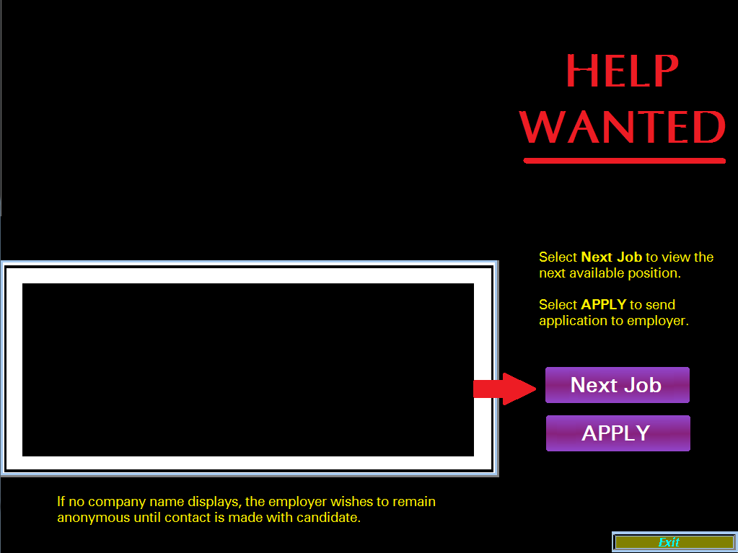

Select the **Next Job** button to view available positions. Every time the **Next Job** button is pressed, a new job is presented. To reset back to the first job, one must exit the **CLASSIFIEDS** menu and reselect **CLASSIFIEDS/FOR HIRE** to view.

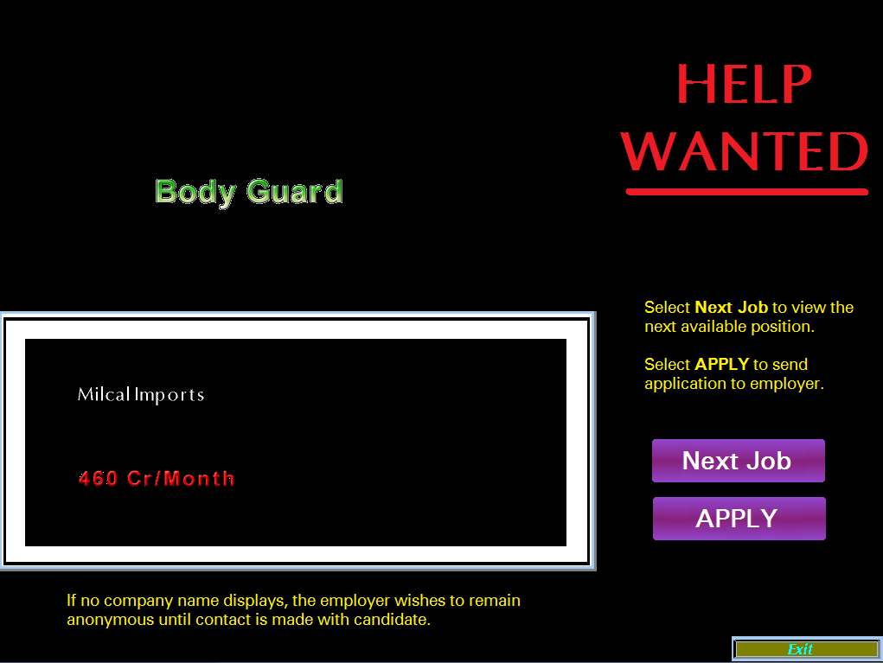

If a player wants to apply for a job, they just need to press the **APPLY** button. This generates a running-tally appended text file located in the /saved/jobs directory using a filename convention of the applicants TAS member number, day, and year. The Referee can view this file to see the necessary job information.

A mail message will be sent to the TAS administrator account notifying the referee of the application.

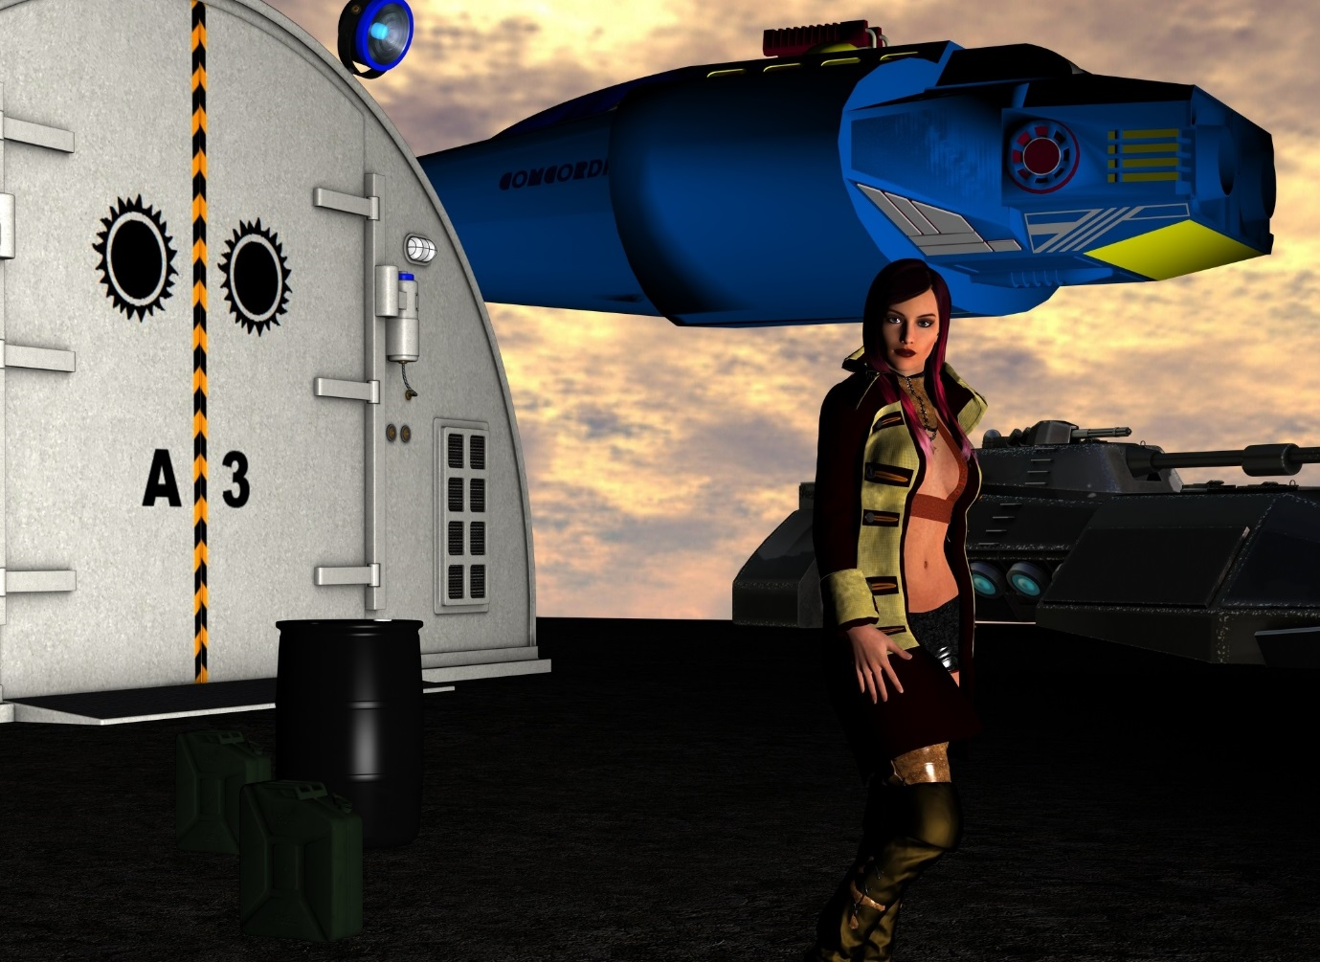

|  |
| --- |
| MENU: Communications 1 |
|  |

The Communications Menu facilitates X-Boat communications between player-player, player-referee, and referee-player. Each message has 19 lines in the body of the message to use. Message mailboxes have a limit of 2000 messages. One a message is read, it is moved to the old message archive for historical viewing.

To start, one needs to have the correct access level to open up the menu:

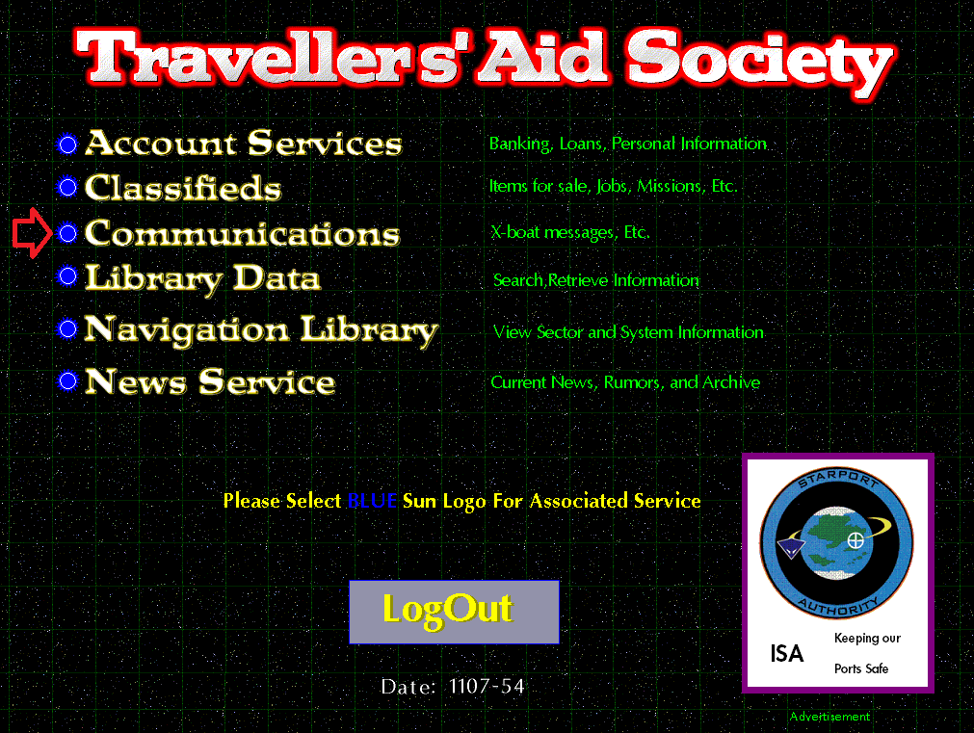

CLICK on the BLUE Imperial Seal 1 for **Communications** menu

## **Message Alert**

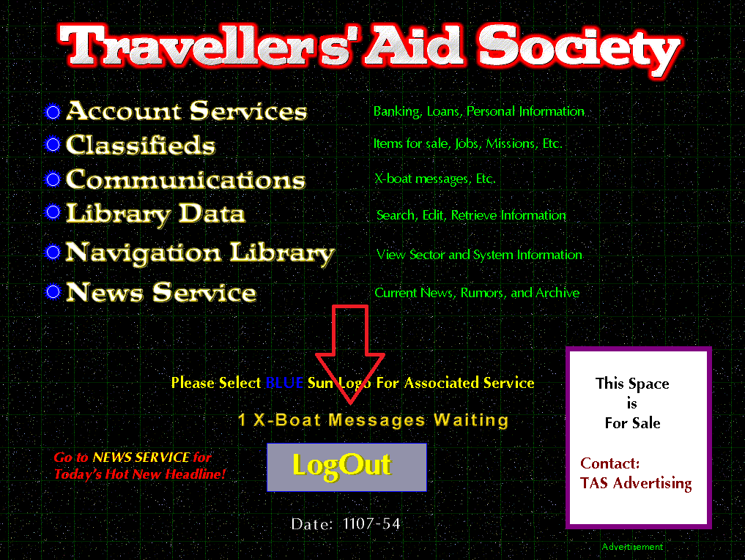

The Send Message menu allows one to create a new message, clear the current draft message, and send the drafted message.

If a message is waiting to be read, an alert will show up on the main menu screen as shown in the screenshot above.

**Communications Menu**

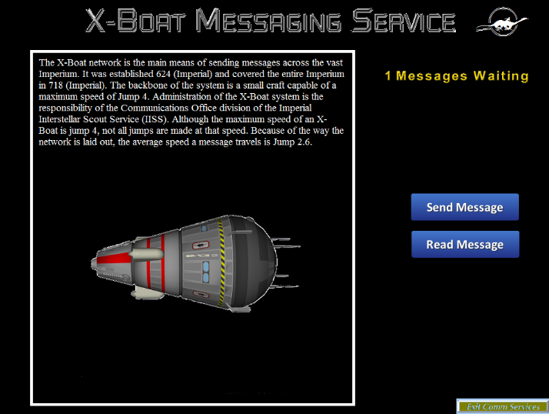

The X-Boat Messaging Service menu has two options: Send Message and Read Message.

**Send Message**

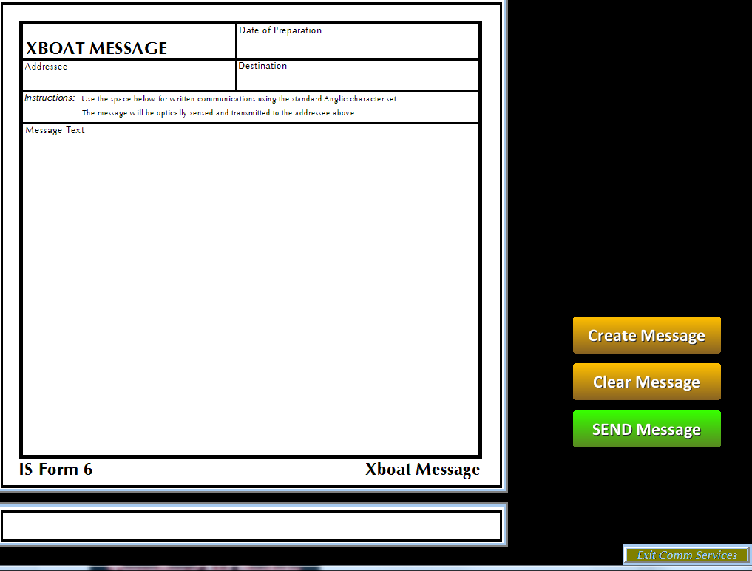

To Create and Send a new message:

1. Select the Create Message button

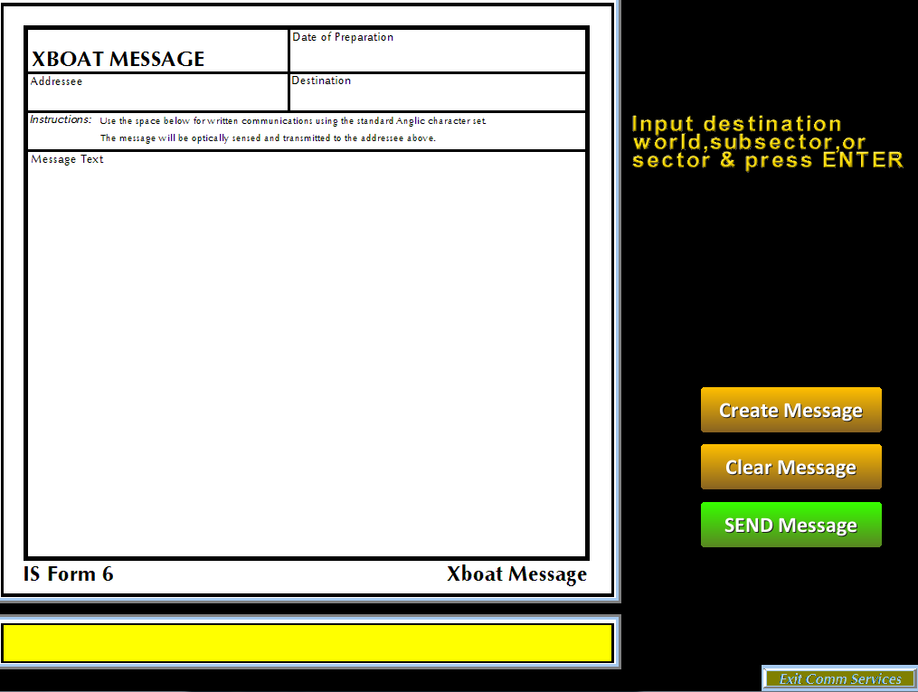

1. Enter the destination of the message (ex: Regina, or Moon Station 12) and press ENTER.
2. Enter the recipient’s name or if it is another player, enter in their TAS Member number and press ENTER.
3. Now input your message. You have to press ENTER after each line entry. You have a total of 19 lines in the message.
4. At the end of the message, type on its own line: [END] and press ENTER to exit the message edit mode.
5. You can clear the message, exit the menu, or send your message by pressing Send Message.

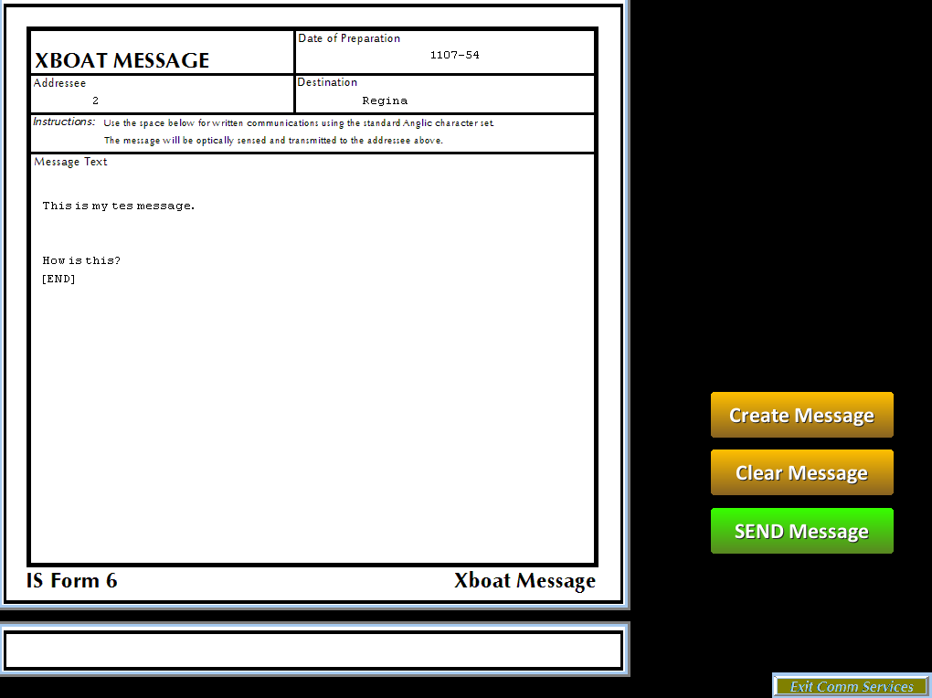

## **Read New Message**

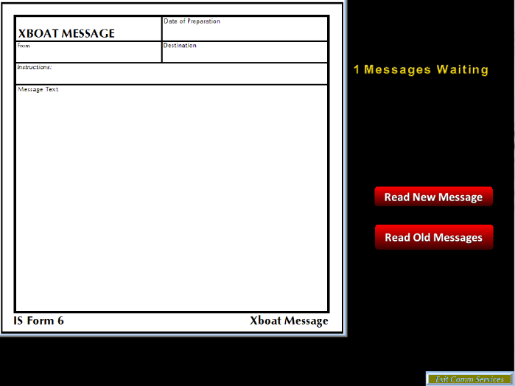When a new message is available to read, select the **Read Message** menu button.

If there are any messages awaiting to be read, the screen will alert you that there is a message waiting.

From this menu you can read both new and old messages. Once a message has been read, it is moved to the Old messages mailbox.

While reading a message, if there are more than 1, you will be presented with a **Next** and/or **Back** button to move forward or backwards through messages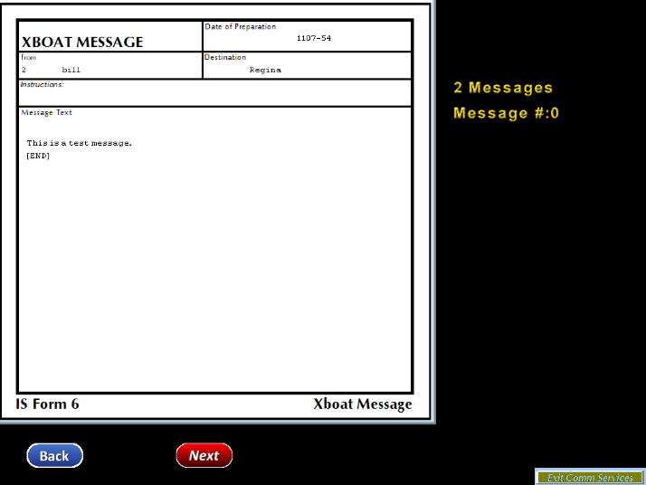.

## **Read Old Message**

Selecting the Read Old Messages button brings up the archive mailbox of all previously read messages.

|  |
| --- |
| MENU: Library Data 1 |
|  |

The Library Data menu option provides the user with the ability to search the Library Data archive. The search is Not case-sensitive. So if one is to search for Ancients, the search word could be “Ancients” or “ancients”.

To start, one needs to have the correct access level to open up the menu:

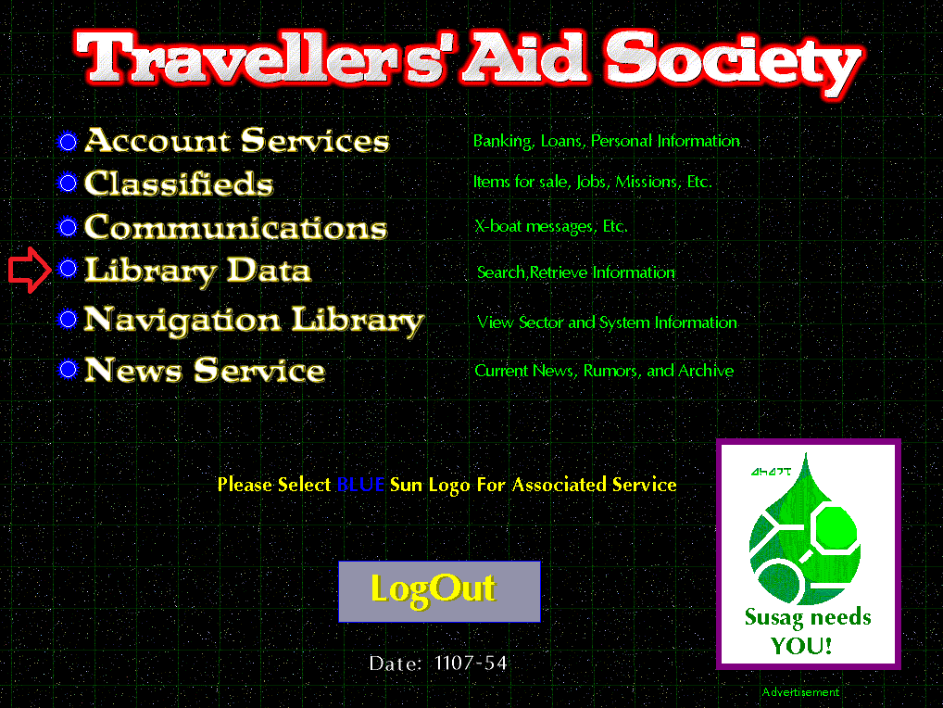

CLICK on the BLUE Imperial Seal 1 for **Library Data** menu

## **SEARCH**

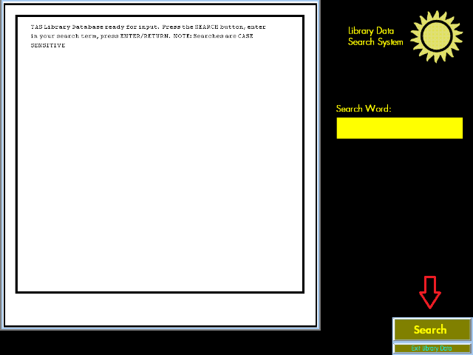

Click the **Search Button** to enter a search word or phrase (max 100 characters, case does not matter) and press the ENTER/RETURN key.

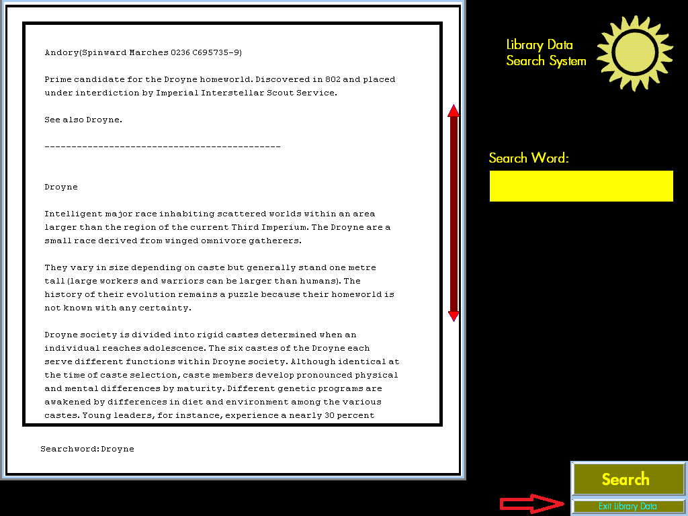

**For Example**: Droyne

Use the **up** and **down** **arrows** to navigate forward and backward through the result.

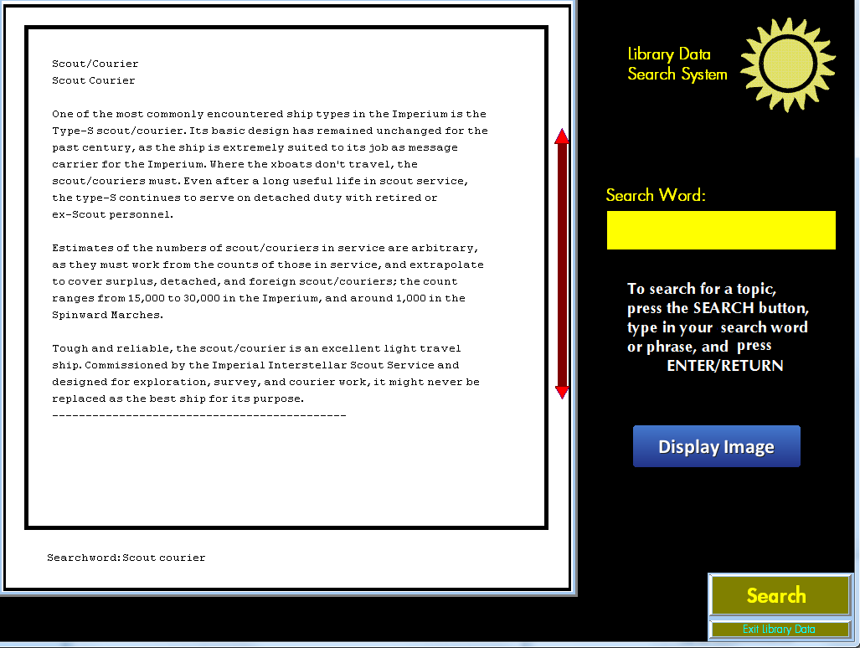

All results show up on the display screen. If there are ***multiple results***, the result data will be separated by a horizontal line (dashes). If the result is larger than what can display on the screen, a vertical navigation bar will be available with clickable arrows for moving up and down the result.

Images

If a library entry has an image associated with it, a  button will appear to view the image.

If there are ***multiple*** search results with images, you will have to narrow down to doing an exact search (specific wording) on text within the specific entry to view the image for that entry.

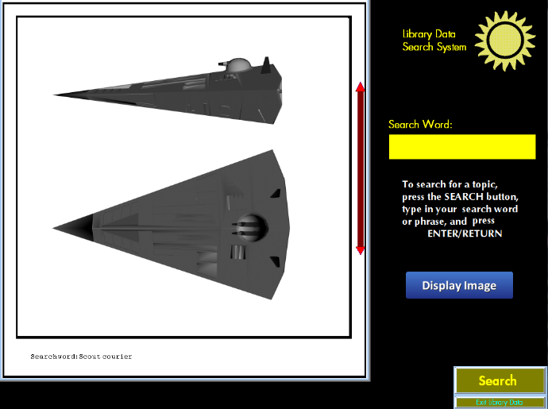

By selecting the  button, the associated image will appear. Click anywhere to exit back to the search result text.

You can **EXIT** the Library Data service by clicking on the Bottom-Right button- **Exit Library Data**.

|  |
| --- |
| MENU: Navigation Library 1 |
|  |

The Navigation Library provides TAS members with star chart information based on various scout and expedition surveys of space. Users can examine various sectors, subsectors, and systems for needed information. If there is any Library Data available for the sector or system, users can view the data. The ability to save the charts generated to bitmap picture files lets users modify the information for their own needs. Additional credit information may be located inside the All.SEC sector file and/or sector number directory.

To start, one needs to have the correct access level to open up the menu:

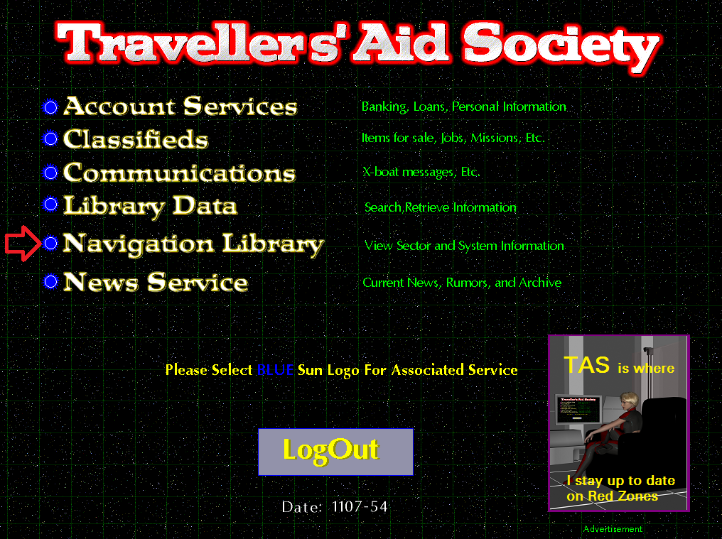

CLICK on the BLUE Imperial Seal 1 for the **Navigation Library.**

## **Known Space Menu**

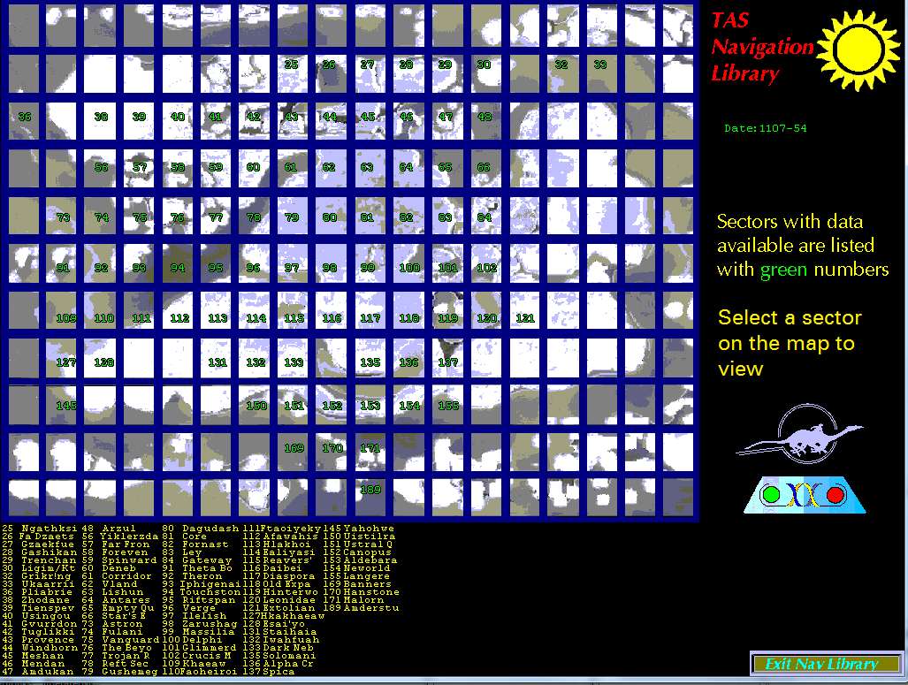

The Known Space menu displays a map divided into 198 sectors. If data is available on a sector, it will be displayed with the sector number in the appropriate sector division. Numbering starts in the upper left corner with 0 and increments horizontally across the map (the very bottom-right is sector 197). The current Imperial Calendar date is also displayed in year/day format on the right side.

There is a list on the bottom of the screen identifying the sector number to the sector name.

Move the mouse over an available sector (one with a number displayed) and click the LEFT mouse button to view the sector.

Move the mouse over the **Exit Nav Library** button and click the LEFT mouse button to exit the Navigation Library.

## **Sector Menu**

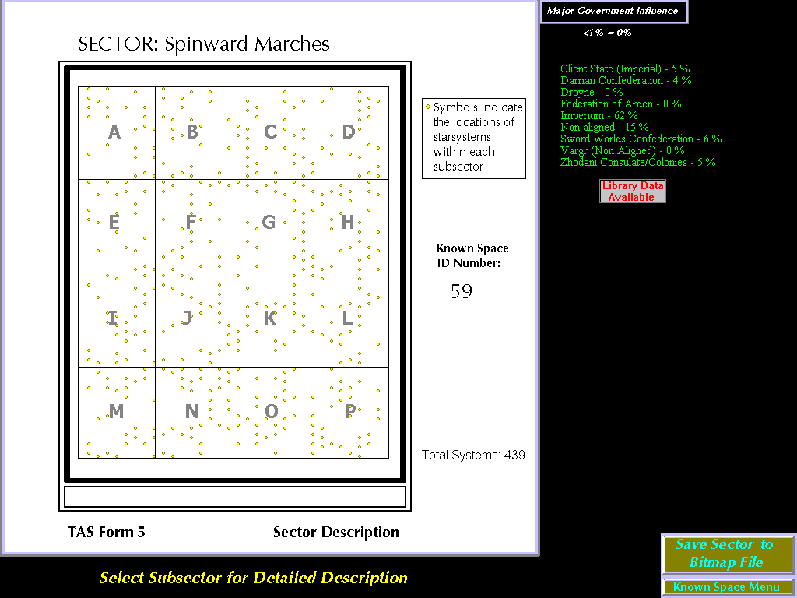

The Sector Menu displays a map on the left side representing the 16 subsectors which occupy it. The right side displays the statistical breakdown of political influences within the sector (alliance and allegiance.) If there is Library Data available describing the sector, a clickable button will show indicating such (as in the picture above).

Move the mouse over a particular subsector (A through P) and click the LEFT mouse button. This will open the Subsector screen.

Move the mouse over the **Save Sector to Bitmap File** button and click the LEFT mouse button to save this sector map to a bitmap picture file in the /SAVED/SECTOR directory of your TAS application installation location on the hard drive.

Move the mouse over the **Known Space Menu** and click the LEFT mouse button to go back to the **Known Space** screen.

If available, a **Library Data Available** button will appear. Clicking this will display the associated library data. You can click on the UP/DOWN arrows to scroll through the library data. Select the **Return to Map** button to exit the library data.

## **Subsector Menu**

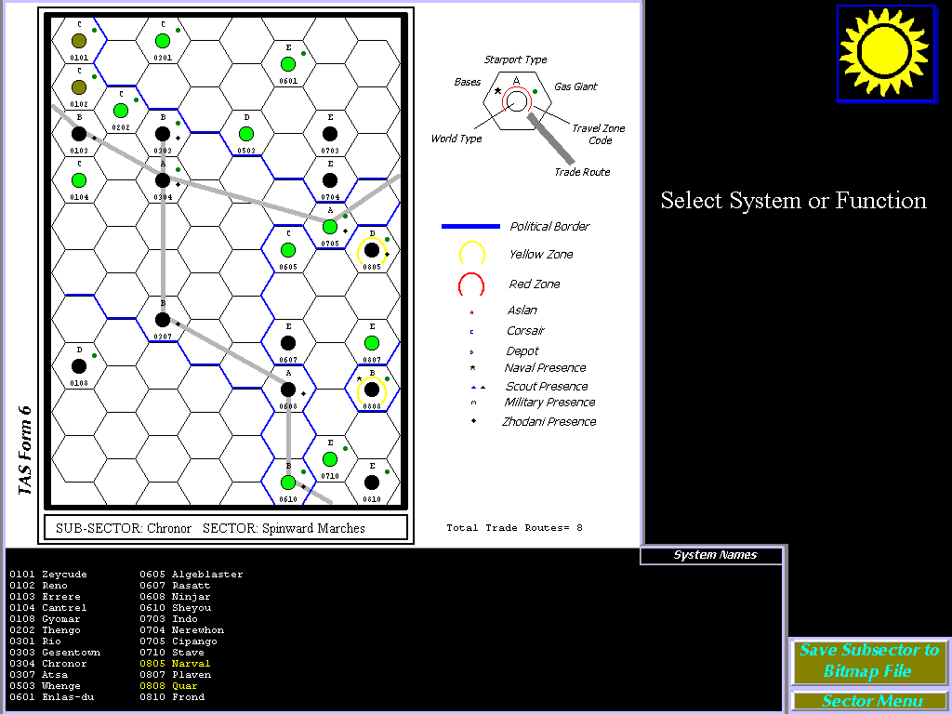

The Subsector Menu is divided up into three sections:

TAS Form 6 Map

The subsector map displays each star system, trade route, and political boarder. The class of starport, bases, and TAS zone classification are also represented.

System Names

A list displaying the hex number and system name is displayed for quick reference. If a system is classified as an amber or red zone, then the color of the listed system will reflect the classification.

System Details

The right side of the screen displays details on a selected system.

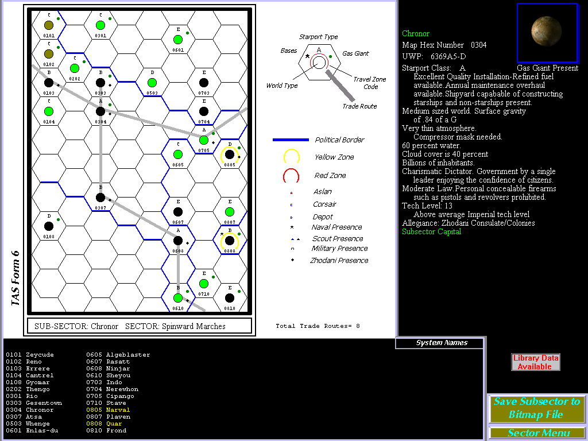

**Usage:**

* Move the mouse over the Save Subsector to Bitmap File button and press the LEFT mouse button to save this subsector map to a bitmap file in the /SAVED/SUBSECTOR directory on the hard drive.
* Move the mouse over the Sector Menu and press the LEFT mouse button to go back to the Sector Menu screen
* If available, a Library Data Available button will appear. Pressing this will display the associated library data.
* Move the mouse overtop a system hex on the map and press the LEFT mouse button. This brings up the system details.
* Move the mouse overtop of the system planet picture (upper **right** corner of the screen) and press the LEFT mouse button. This brings up an icosahedral map of the main planet.

## **Sector and Subsector Library Data**

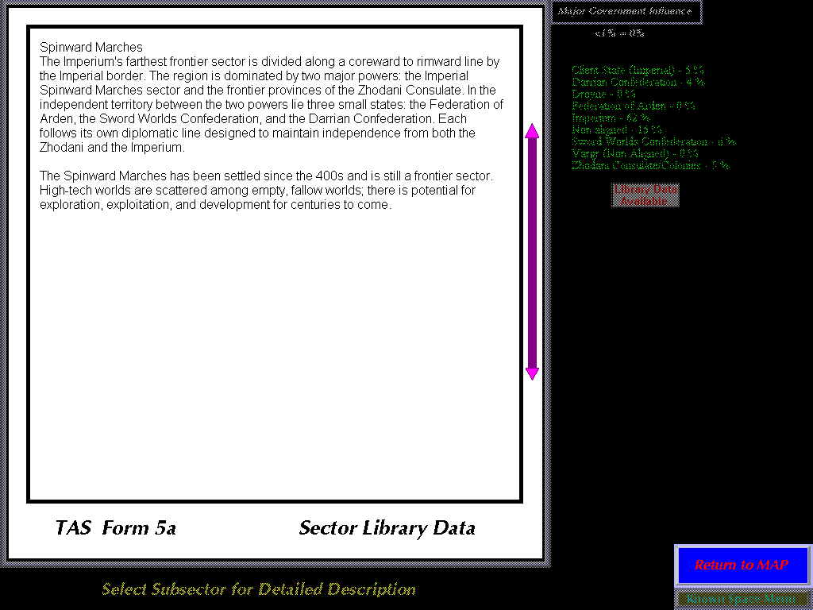

If there is library data available, the availability button will appear on the right pane. By left mouse clicking on the button, the library data will appear in the left pane.

While library data is being displayed, move the mouse overtop either the **top** or **bottom** **arrow** on the scroll bar and press the LEFT mouse button to scroll through the text of the data. If there is more data than can fit on the *TAS Form 5a* screen, then the arrows will appear.

**Picture**

If the library data has an image associated with it, then a  button will appear to the right that you can click on to display the picture.

After viewing the picture, click anywhere to get back to the library data display.

## **Planet Map and System Orbits**

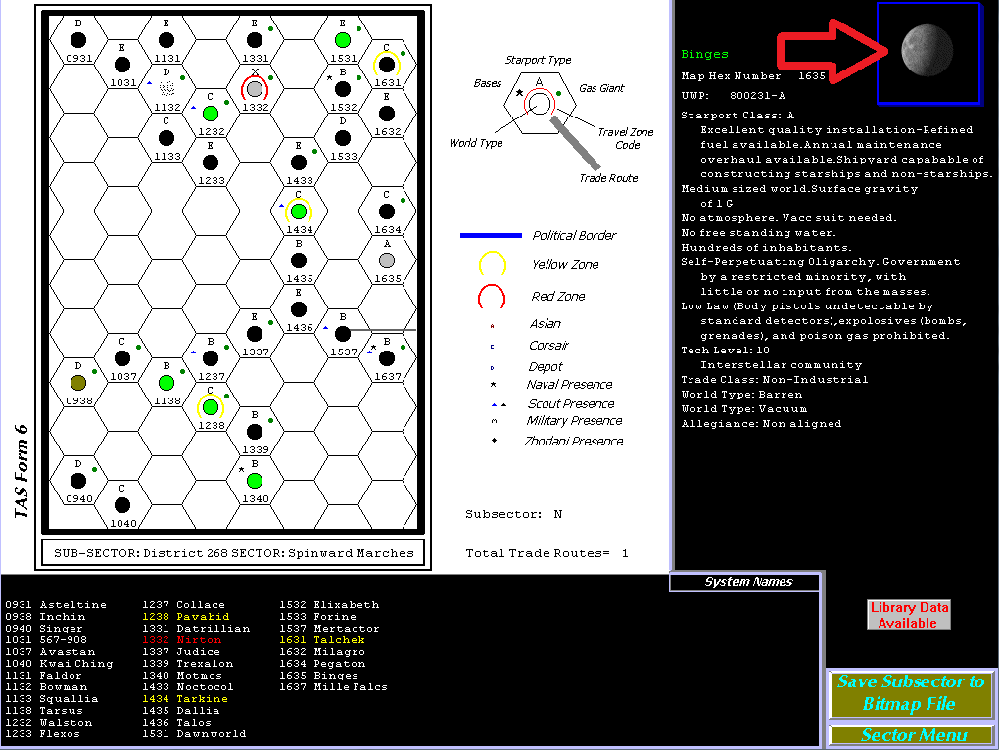

Move the mouse overtop of the system planet picture (upper **right** corner of the screen) and press the LEFT mouse button. This brings up an icosahedral map of the main planet using Imperial Scout *Form IS 8* plus trade goods based on T5 rules.

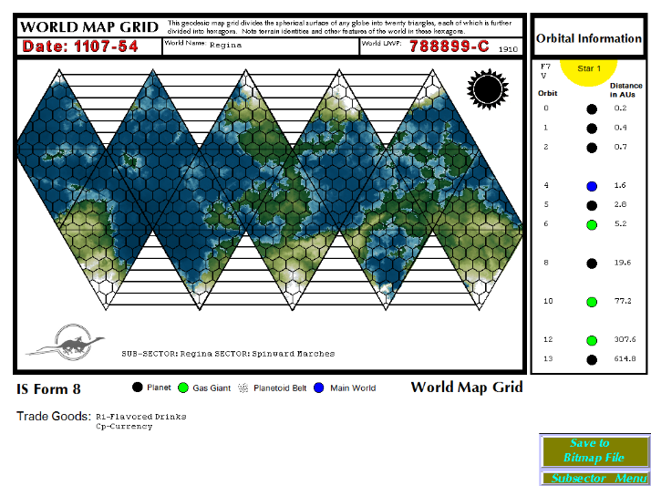

By clicking on the **Save to Bitmap File** button, you can save the planet map to /saved/planet directory or **Exit** back to the subsector menu screen.

In addition to *IS Form 8* required fields, the addition of Sector, Subsector, and Hex number are included. The colormap used for the various maps are based on *elevation* and *worldtype*. They are not exact and may not truly represent the world. The random seed used to generate each map is the world’s UWP number + Hex location. This allows the display of the same map every time one selects the particular world.

A custom map can display also (see *Administration* chapter of this document for more information)

**Examples:**

**Desert world**

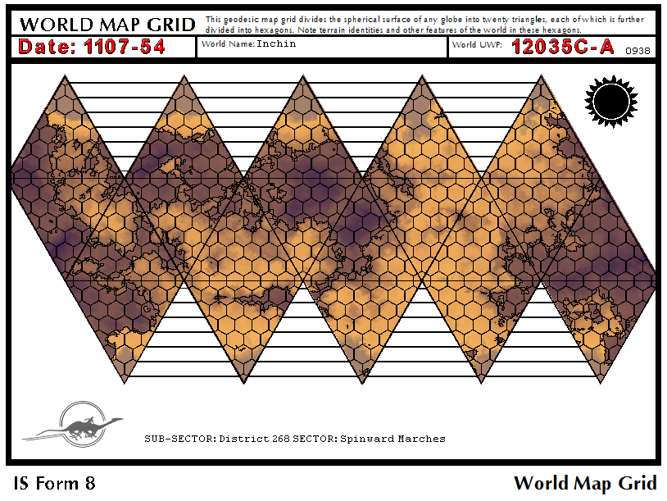

**Garden world**

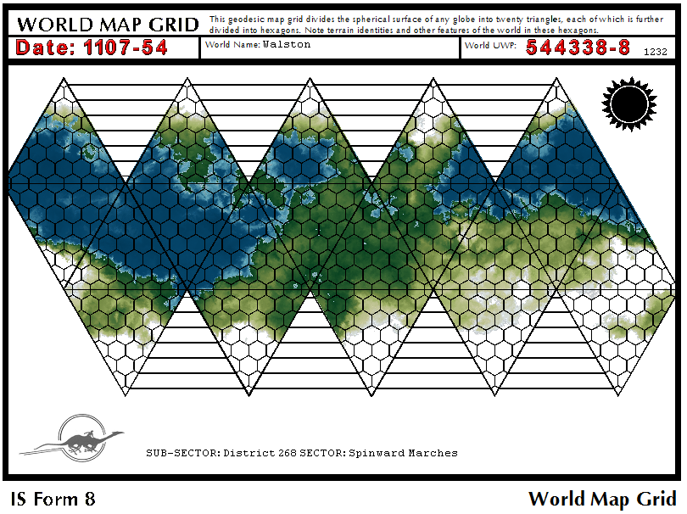

**Normal world**

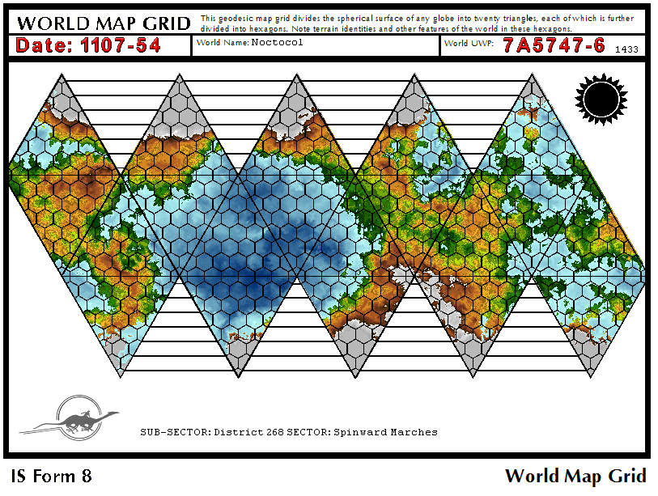

**Barren world**

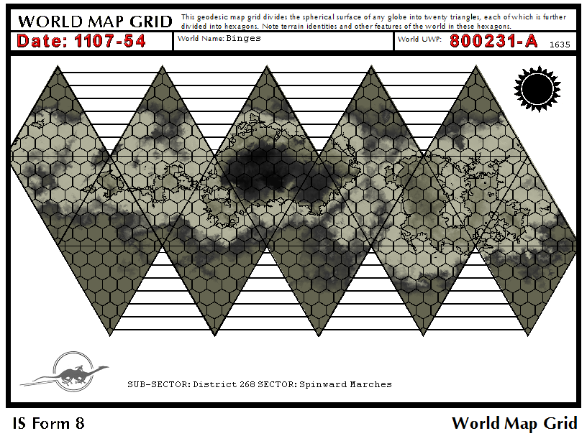

**Water world**

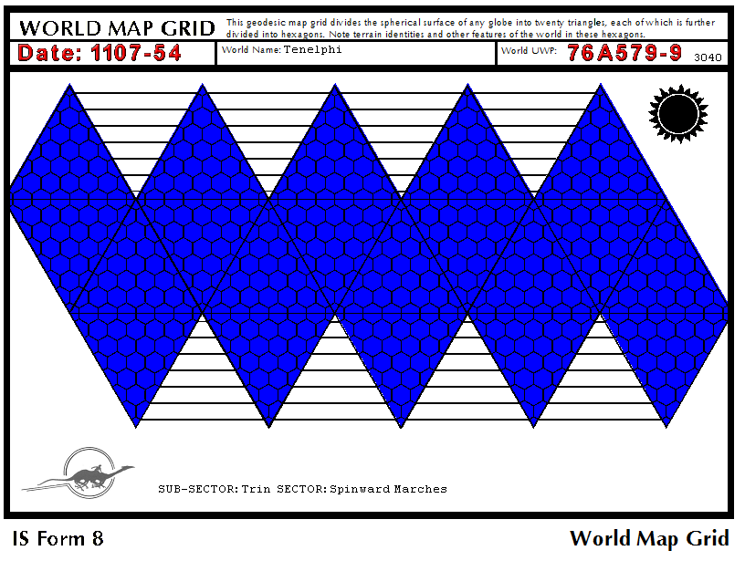

**Asteroid**

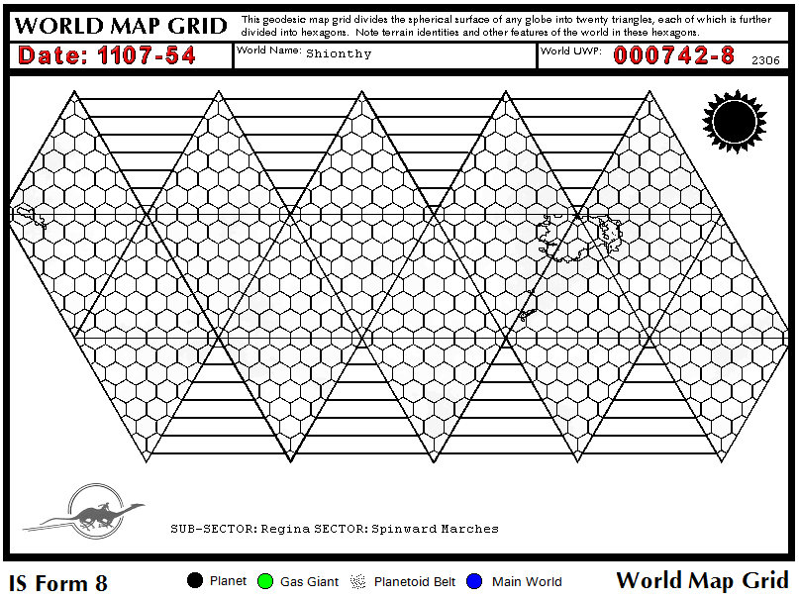

Orbital Information

Orbital placement information for the solar system is located on the right side of the map. This information displays the various bodies located within an orbital band. This information is generated from the system UWP file entry using the PBG (Planets, Belts, Gas Giants) data field. The orbit and planet placement is based on the MegaTraveller™ System Generation rules and tables for Stellar Classification and Orbits. Orbital Information will only be displayed for the primary star in the system. If there is a discrepancy in the source data file (usually PBG data is not compatible), no information will display. The key below shows the various bodies displayed:



**Example orbital information:**

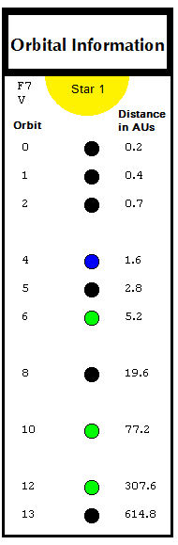

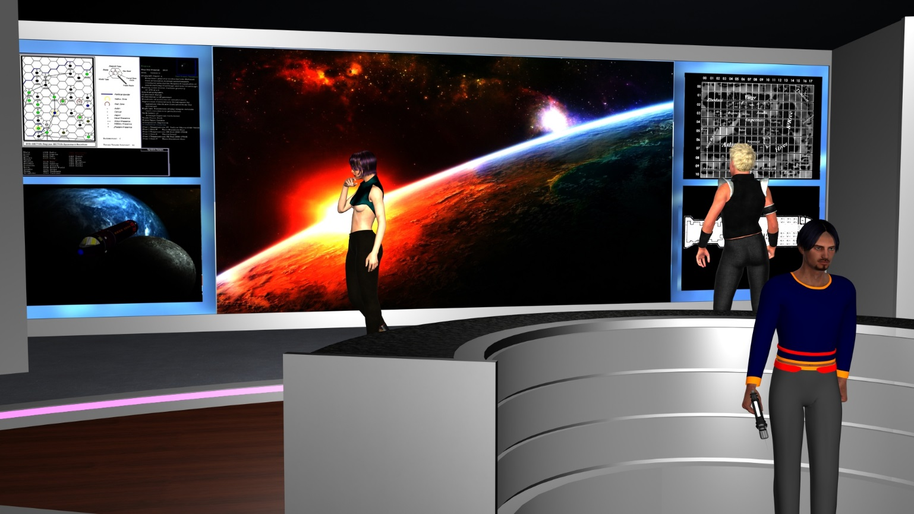

|  |
| --- |
| MENU: News Service 1 |
|  |

The TAS News Service provides TAS members with current news from around the known space. In addition to current news (past 45 days recency), a TAS member can view the archive of past news articles and also view various rumors.

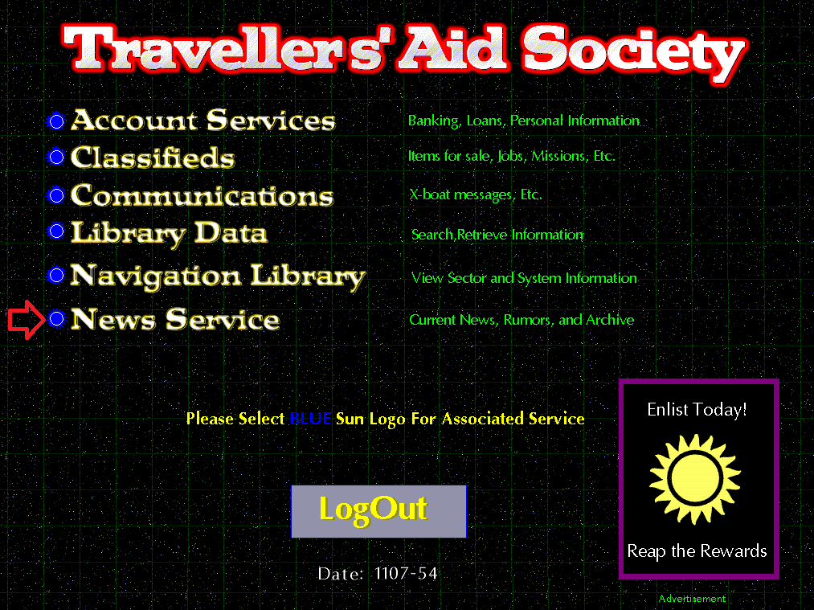

**News Service Menu**

The News Service Menu displays the current Year and Day as well as a reverse-order list of news for the past 45 days. The current year and day can be set by editing the tas.ini file located in the root directory of the TAS binary application. There are also buttons to view the **archives** of *news files, rumors*, and to return to the **Main Menu** by exiting the News Service.

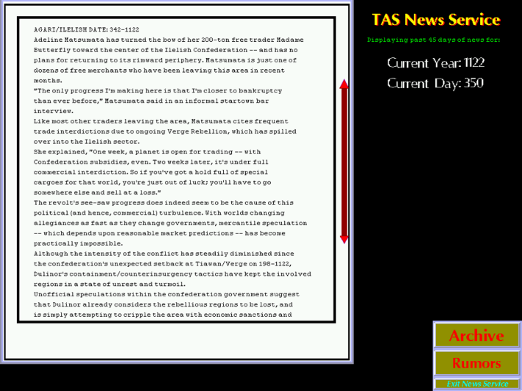

If there is a substantial amount of news information, UP and DOWN arrows will be present. Move the mouse over the appropriate **arrow** and **LEFT CLICK** to jump forward or backward through the news articles.

Move the mouse over the **Exit News Service** button and press the **LEFT** mouse button to exit the News Service Menu.

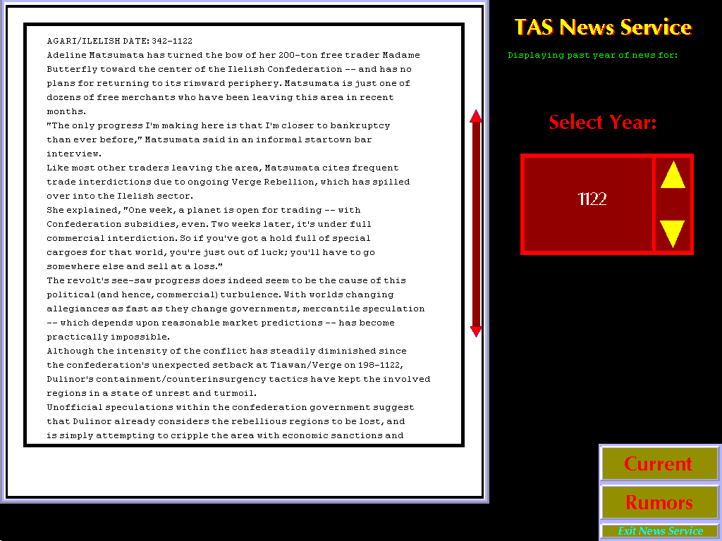

Selecting the **ARCHIVE** menu selection will bring up a display reflecting the entire year of news for the displayed year. If the displayed year is the current game year, then the year to date will be displayed. You can click on the **yellow arrows** to view previous years’ news archives.

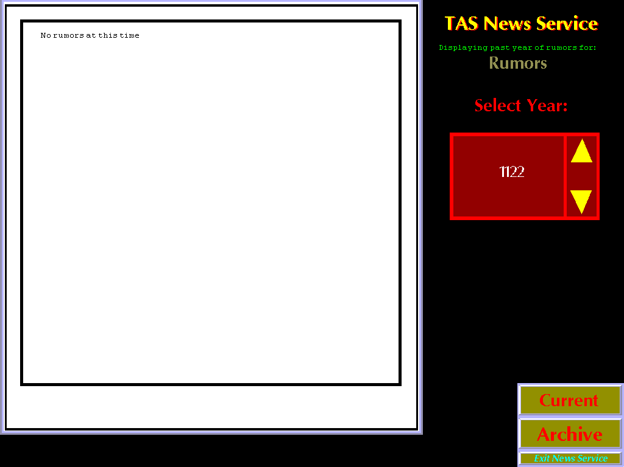

Selecting the **RUMORS** menu selection will bring up a display reflecting the entire year of rumors (news from non-legitimate sources) for the displayed year. If the displayed year is the current game year, then the year to date will be displayed. You can click on the **yellow arrows** to view previous years’ rumors archives.

**News Era**

The default menu graphics are set for TNS (Travellers’ News Service). If the ERA is set to TNE, the graphics change to the Coalition Information Network.



.

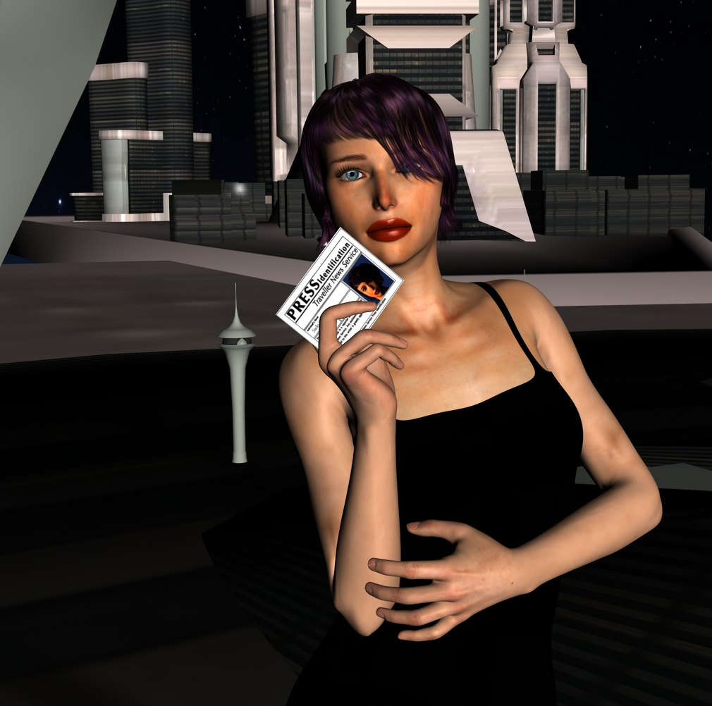

|  |
| --- |
| Administration of the TASAT Application 1 |
|  |

To make the TASAT application usable for your gaming campaign, you should customize it for your players. Two files are most important for the application to run correctly, the TAS.INI file and the ACCOUNT.INI file. Both are described in detail below.

**TAS.INI**

The TAS.ini file contains configuration parameters that are used by the various TASAT applications. Using a text editor such as Notepad.exe, these settings can be changed (usually by the Referee who is administering the game to players.) Each parameter must be followed by a carriage return. Word-wrapping text is not valid and may cause problems for the TASAT applications. Each application can draw upon the settings from this file.

Example TAS.INI file:

# Travellers' Aid Society Access Terminal

# TAS.INI initialization file

VERSION=2.43

#

#

# Set era for resources

# 1=Classic/MegaTraveller 1070-1116

# 2=Traveller the New Era 1116+ (1200)

# 3=Milieu 0 (T4)

# 4=Custom

# 5=T5

#

ERA=1

#

#

# Set Current Year (ie 1085)

# Set Current Day (1-365)

#

YEAR=1107

DAY=54

#

#

# Access levels range from 0 to 9

# 0=basic user

# 1=TAS charter membership

# 2-9 are members with access to special areas

# 10=Administrator

#

# Set access level number for each area for access

#

# Navigation Library

ALNAVLIB=2

# TAS News Service

ALNEWS=1

# Library Data

ALLIBDATA=3

# Account Services

ALACCNT=0

# Classifieds

ALCLASS=1

# Classifieds-Missions/Mercenary tickets

ALMERC=4

# Xboat Communication Message Services

ALXBT=1

The pound symbol (#) is used for making comment lines. The # is placed at the beginning of a line or statement that is NOT to be read by an application.

**Version, Era, and Date**

The VERSION number is used in conjunction with the version number encoded in the compiled binary application. When you install a newer version of the binary executable, the TAS.INI file version # needs to be set to the same version as the binary. Otherwise the program will not run. This is a safeguard for keeping your TAS.INI file up-to-date with the latest functionality and settings requirements. Each newer version of the application comes with a file TAS.INI.NEW that is formatted with the latest settings. You should compare this file with your existing TAS.INI file to see what has changed and make adjustments to your TAS.INI file (including the version #).

The above example shows three settings: *ERA*, *YEAR*, and *DAY*. The values after the equals sign can be modified by a Referee. This allows the Referee to set the Traveller era, year, and Imperial Calendar day. Each application section which needs to know the date will use the date specified for the *YEAR* and *DAY*. The *ERA* lets the application draw upon resources from the Era-specific directories and files.

For Example:

If the *ERA* is set to equal **1**, then the Navigation Library will use the sector files located in the /sectors/classic subdirectories. Other TASAT applications will also draw from the /librdata/classic and /news/classic directories for its resources. If a Referee needs a resource that is available in one era to be also available in another era, then the Referee will have to copy the files from one era directory to the other.

**Access Levels**

Users are assigned various access levels in the /accounts/users/account.ini file. To gain access to a specific menu item, their level must meet or exceed the level defined in the tas.ini file:

[…snippit of tas.ini file]

#

# Set access level number for each area for access

#

# Navigation Library

ALNAVLIB=2

# TAS News Service

ALNEWS=1

# Library Data

ALLIBDATA=3

# Account Services

ALACCNT=0

# Classifieds

ALCLASS=1

# Classifieds-Missions/Mercenary tickets

ALMERC=4

Here we see that a user must have an access level of **2** or greater to access the Navigation Library but only an access level of **1** or greater to access the News Service.

|  |  |  |
| --- | --- | --- |
| **Access Level** | **Membership** | **Notes** |
| 0 | none | Account Svcs Only |
| 1 | TAS Charter Member |  |
| 2-3 | TAS Bronze Member |  |
| 4-7 | TAS Silver Member |  |
| 8 | TAS Gold Member |  |
| 9 | TAS Lanthanum Member |  |
| 10 | TAS Administrator |  |

**Accounts**

There are two types of accounts for each user. One is a *bank* account, the other is the *login* account. The login account file is found in the /accounts/users directory using the file account.ini. An example of this file is listed below:

ACCOUNT.INI

# Travellers’ Aid Society Access Terminal

# ACCOUNT.INI initialization file

#

#

# NOTE: Each record/account entry must follow the below order and format:

#

# NAME=user name [up to 30 characters]

# PW=password [up to 30 characters]

# UPP=UPP of the character [ex:777777]

# HW=Homeworld

# RA=Race

# AL=access level [number]

#

#

NAME=john smith

PW=bonk

UPP=777777

HW=Regina

RA=Human

AL=0

MBR=1

#

NAME=bill

PW=wow

Pound (#) symbols are used for comments. Each account contains seven lines:

NAME=

PW=

UPP=

HW=

RA=

AL=

MBR=

*NAME* is the user name and can be up to 30 characters in length

*PW* is the password for the user which can be up to 30 characters in length

*UPP* is the player’s UPP number

HW is the player’s homeworld name (can be name, location, sector, etc.)

RA is the player’s race

*AL* is the access level for the user ranging from 0 through 9. A user with access level of 0 will be able to log in but only have banking services available. Whereas a user with access level of 1 might have access to the Navigation Library. AL of 10 is the administrator level (Referee). You should only have one access level 10 user.

*MBR* is the unique TAS member number. You set this. No duplicates.

***Note*: These entries MUST be in sequential order (NAME, PW, UPP, HW, RA, AL, MBR) separated by a # between accounts.**

**Sector Files**

The TASAT allows up to a total of 198 unique sectors for viewing (known space). Each sector is located in its own file system directory named by its location number. The following map describes the numbers associated with its proximity location in space.

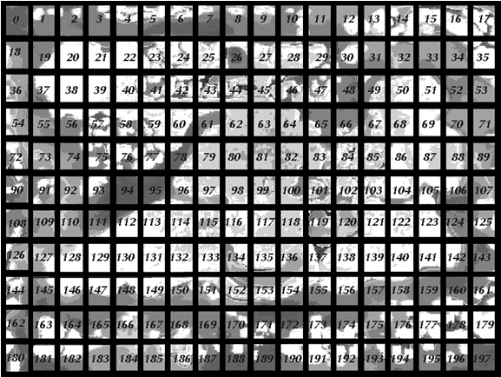

As a reference point, sector 59 is the Spinward Marches, and sector 81 is Core

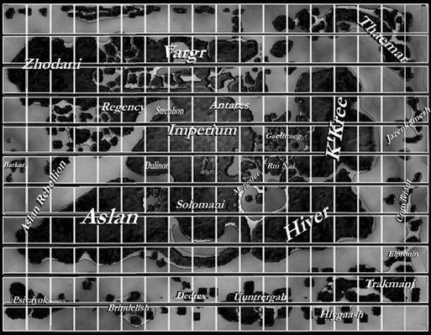

The sector files are broken into four unique types:

* System Library Data
* Sector Library Data
* Sector Data
* Subsector Data

System Library Data

Library data information on a particular system is stored in the /sectors/*era*/*sector number*/data directory. The *filename* is identified by the letter “**h**” followed by the four digit hex location for the system. Here is an example:

H0415.txt

This file would contain text describing the system located in hex 0415. The library data files for systems do not need to contain a carriage return at the end of each line. The text can be word-wrapped. This allows you to easily associate library data to a system (just create the text file and name the filename using the above format).

As with normal library data images (see *Custom Picture Image association with a Library Data* entry [page 39]), you can add an associated bitmap jpeg image to an entry (616x594 24-bit bitmap jpg). Just put @@@@*filename*.*jpg* on its own line (usually at the end of the file) followed by a carriage return. Put a copy of the .jpg file, named whatever you named it, in the the /sectors/*era*/*sector number*/data directory.

Sector Library Data

Library data information describing a sector is stored in the */sectors/era/sector number/data* directory. The filename is ALL.txt

Like the system library data, the sector library data can be a word-wrapped text file. Sector library data does not use the bitmap picture option.

Sector Data

The sector data files are located in the /sectors/*era*/*sector number*/ directory with the filename ALL.sec

This is a compilation of all 16 subsector data files. It is used to display the whole sector screen in *TAS Form 5* format.

Subsector Data

The subsector data files are located in the /sectors/*era*/*sector number*/ directory with the filenames SEC_A.sec through SEC_P.sec. Sector I and Sector O are valid and required with TASAT. These files are used to display each subsector screen for *TAS Form 6* format.

Sector File Template

In the /Templates directory there is a text file called template.txt which can be used to keep the formatting of new sector files in accordance with the Genie format that the TASAT applications use.

The following is what template.txt includes:

@SUB-SECTOR: Mapepire SECTOR: Beyond

#

# Trade routes within the subsector

#src. dst. X Y dst. offsets

# $1840 1841 0 1

#

#Political Borders

#hexnumber hexside(0-5)

#^1840 0

#^1840 1

#--------1---------2---------3---------4---------5---------6---------7--

#PlanetName Loc. UPP Code B Notes Z PBG Al. Star(s)

#---------- ---- --------- - --------------- - --- -- --------------

The ALL.sec file also follows the same format.

**@** The data following the @ symbol should use the following schema:

For subsector files-

@SUB-SECTOR: *subsectorname* SECTOR: s*ectorname*

For sector files-

@SECTOR: s*ectorname*

Each line is read from the file in turn. The first character of the file (the tag) determines what the data on that line represents.

**#** Is used to put any comments after.

Example: #this is a test

**@** Names the SECTOR/SUB-SECTOR for the file.

Example: @SUBSECTOR: A SECTOR: Vland

**$** This symbol is used to denote a single trade route. The first 2 fields are the beginning and ending hex locations. The last 2 fields are offsets for the end location if it is outside the border of the sector currently being displayed. If this type of segment is entered, the segment end that is INSIDE the subsector must always be listed first. The offsets indicate in which direction the destination is off the map, but are not required to indicate how far. For the X coordinate, -1 is to the left and 1 is to the right. For the Y coordinate, -1 is up (this is X Windows, remember?) and 1 is down. Segments with both ends outside the subsector cannot be used. All 4 fields MUST appear in the columns shown.

Example: $1005 1307 0 0

**^** This symbol denotes a segment of a political, military, or cultural boundary/border. The first field is the hex location and the second field is the edge of the hex. Hex edges are numbered from 0 to 5, clockwise, starting with location 0 at the top of a hex. Additional information on the use of this symbol is described under Political Boarders below.

Example: ^0112 4

Any line in the file starting with a character other than those listed above is assumed to be an entry for a star system within that subsector and must be in the format shown above. Each star system entry contains (from left to right) name, hex location, UPP code, Base code, system notes, TAS zone code, # of solid planets, # of asteroid belts, # of gas giant data (PBG), allegiance code, and star types. These field MUST appear in the columns shown.

These values are the 6 points of each hex, arranged in a 6-point format. The points are ordered as follows:



Each segment listed in the subsector file has the following format (starting in column 0):

^nnnn m

Following the carat (^), the *nnnn* value is the hex number and the m value is the 6-point side number of the hex. Valid values for *n* are 0 through 5, with the top edge of the hex as the 0 edge, and the other edges numbered clockwise.

An example showing both trade routes and political boarders can be found in the /sectors/classic/59/sec_a.sec file.

Systems

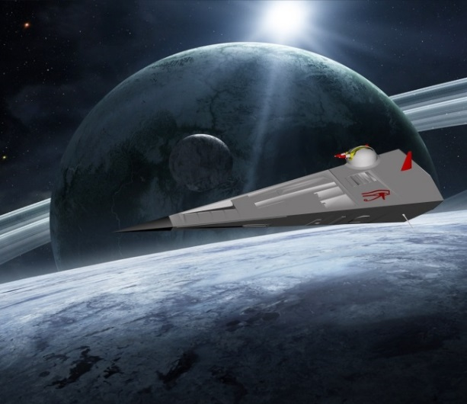Systems within a sector or subsector file are described on a single line entry followed by a carriage return. Each line is 80 characters long and contains system information in the following space locations:

|  |  |
| --- | --- |
| **Line Cell Location** | **Description** |
| 1-13 | Planet or system name |
| 14-17 | 4-digit system hex location number |
| 19-27 | System UPP |
| 30 | Base type |
| 32-46 | System notes |
| 48 | Zone (R=red A=amber) |
| 51-53 | Number of (P)lanets (B)elts (G)as giants |
| 55-56 | Allegiance code |
| 58-78 | Stellar information |

Here is an example entry line:

Quar 0808 B532720-B N Na Po A 401 Im M2 V

If we examine this line with the cell key above, the information location and method becomes more apparent-

#--------1---------2---------3---------4---------5---------6---------7-

#PlanetName Loc. UPP Code B Notes Z PBG Al. Star(s)

#---------- ---- --------- - --------------- - --- -- -------------

Quar 0808 B532720-B N Na Po A 401 Im M2 V

Stellar star data will support up to four stars per system. The format follows the star data outlined in MegaTraveller™ System Generation rules and tables for Stellar Classification and Orbits. Also included is classification Q (neutron star) and X (black hole).

Stellar Morgan–Keenan (MKK)

classification heat and size chart for stars

Planet Maps

You can add your own planetary maps to substitute what the program generates. Copy the planet bitmap template file (*planetmaptemp.bmp*) located in the /templates directory to the sector/*era/sectornumber*/data directory. Edit your map with a paint program. Rename the bitmap file to the system hex number (eg: 1811.bmp) Those with a leading zero, like in 0127 remove zero and name 127.bmp. Now every time someone clicks on the system and wants to view the planet map, your custom map is what is displayed. Several of these have been pre-populated with the program distribution.

Example: /sectors/classic/59/data/1628.bmp

If you want the application to generate its own map instead, just delete your custom bitmap file and the program will revert to generating the map on its own.

**Classifieds Advertisements**

The classifieds section for *spacecraft*, *groundcraft*, and *items* are 500x480 24-bit bitmap jpeg files. The sale of the day for each category is randomly generated when the TAS program starts. The ad and filename numbers do not need to be sequential.

Spacecraft filenames range from 1 to 100 and are prefixed with an "S". Example: S23.jpg

Vehicle filenames range from 1 to 100 and are prefixed with a "V". Example: V100.jpg

Item filenames range from 1 to 100 and are prefixed with an "I". Example: I2.jpg

**Main Menu Advertisements**

The main menu randomly displays advertisements from various companies, TAS, and official governments. These are 24-bit bitmap picture files located in the /bmaps/advertisements directory. Each picture advertisement file is 200x250 pixels. There can be a total of **20** advertisement files. They are named ad1.jpg through ad20.jpg. Some sample advertisements have been included while the remainder are blank ad space for you to edit with your own.



200x250 24-bit color sample advertisement 200x250 24-bit color blank ad space

**Library Data**

The source for the Library Data service is a standard text file named library.txt located in the appropriate Era’s directory:

librdata/classic

librdata/M0

librdata/TNE

…

This file is where official and/or published library data should be entered.

The separator for data within the text file library.txt is four carets ^^^^. Below is a sample snippet of data reflecting this:

Adair

Archduke of Sol, Grand Admiral of the Rim. Adair's great grandmother held the post of Grand Admiral of the Rim during the Solomani Rim War, and was rewarded with the Archduchy.

^^^^

Addaxur

Intelligent minor race of six-legged carnivores from a high gravity world 40 parsecs from Zhdant ( Gavel / Zhdant 2719). This world is in Subsector-G of Tienspevnekr sector.

The Addaxur had established an empire of 37 worlds, with communications maintained by sublight ships, by the time the Zhodani discovered them in -5110. The Zhodani observed the fringes of the empire for about ten years before making open contact in -5120. Carefully planned overtures established friendly relations and reserved 10 of the Addaxur's 37 worlds for the Addaxur without restricting Zhodani expansion.

^^^^

Notice the terms Adair and Addaxur each have a definition terminator of ^^^^ at the end of their definition.

Custom (non-canon, your own) Library Data

There also is a file named mydata.txt which can be edited and contain your own unique library data. Both files are searched together to produce a result. The separator for data within the text file mydata.txt is four carets ^^^^.

Below is a sample snippet of data reflecting this:

Wheatgrass

Strange plant in the Glimmerdrift Reaches.

^^^^

Bogol

Ancient Aslan dice game.

^^^^

Notice the terms Wheatgrass and Bogol each have a definition terminator of ^^^^ at the end of their definition.

Custom Picture Image association with a Library Data entry

You can add images to Library Data by creating a 616x594 24-bit bitmap jpeg file and placing it in the appropriate library data folder.

Let’s say you have a picture of an Aslan for the Classic Traveller Era. You can create a 616x594 jpeg file, name it aslan.jpg and place it in the librdata/classic folder.

Now within the mydata.txt or library.txt file, you would go to your entry for Aslan. Within the body of the text on its own line (preferably before the data end terminator ^^^^) you would add @@@@ with the filename immediately following:

@@@@aslan.jpg

Now when you do a search for Aslan, the image will be available to view.

Example: /librdata/classic/IISS.jpg

Imperial Interstellar Scout Service

The Imperial Interstellar Scout Service (IISS) is the exploratory arm of the Imperium.

It has its origins in the initial explorations of the Imperium's frontiers. Long ago, however, the Scout Service expanded its responsibilities to cover more than mere exploration. It now maps the territory it once explored, and it is responsible for providing navigational charts and maps to the ships that now travel through that territory. In addition, the Scout Service provides long distance courier or postal services between points within the empire.

@@@@IISS.jpg

**News File Format**

News files are located in the /news directory off of the binary root directory. In the news directory there are the various eras for campaigns. Within an *era* directory, there are directories for each year in the era. Within the year directory there can exist standard carriage-returned text files. These files contain the actual news articles. These files are named by the day followed by .txt as in the following example:

327.txt

This file contains the news for the day 327.

Rumors are identified by adding a lower-case letter r as a prefix to the filename:

r327.txt

This file contains rumors announced on day 327.

|  |
| --- |
| System Troubleshooting 1 |
|  |

If the system is not behaving correctly, the first thing to do is read what was written to the error.txt file. This file is located in the main directory where you installed the TASAT application. This file erases itself every time the TAS application starts so it reflects your last use of the application.

Make sure you have followed the installation instructions pertaining to the tas.ini and accounts/users/account.ini files.

Please send an email to [perry1@liberated-technologies.com](mailto:perry1@liberated-technologies.com) with any issue.

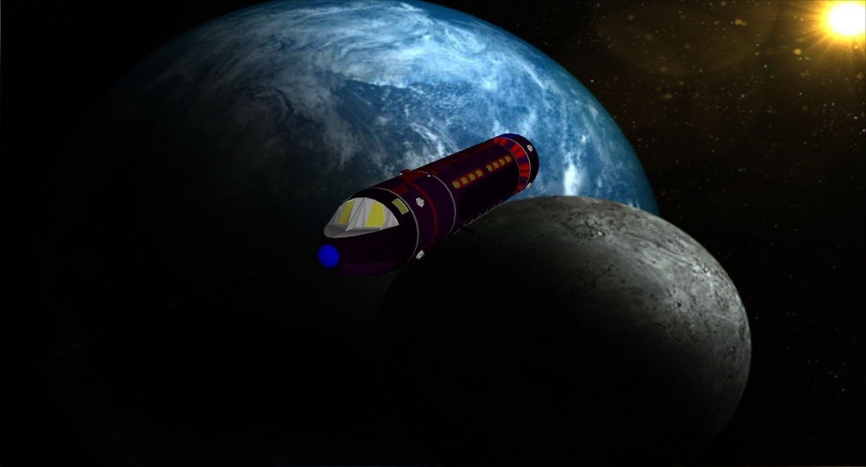

|  |
| --- |
| Appendix A: Allegiance Codes 1 |
|  |

Allegiance Codes

The following is a list of all allegiance codes recognized by the TASAT application. These codes are usually represented within sector files and extended UWPs.

-- Barren World in the Wilds

A Domain of Alntzar

A0 Yerlyaruiwo Tlaukhu Bloc

A1 Khaukeairl Tlaukhu Bloc

A2 Syoisuis Tlaukhu Bloc

A3 Tralyeaeawi Tlaukhu Bloc

A4 Eakhtiyho Tlaukhu Bloc

A5 Hlyueawi/Isoitiyro Tlaukhu Bloc

A6 Uiktawa Tlaukhu Bloc

A7 Ikhtealyo Tlaukhu Bloc

A8 Seieakh Tlaukhu Bloc

A9 Aokhalte Tlaukhu Bloc

Ac Anubian Trade Coalition

Ae Aellelaek Ksafi

Ak Akeena Union

Am Amondiage

Ar Aoiftu Roakh

As Aslan Hierate/Colonies

AU Akigura Union

Au Amalgamation Union (Gold Union)

Av Avalar Consulate

Aw Yehaso Clan (Aslan)

B The Biumvirate

Ba Confederation of Bammesuka

Bc Backman Cluster

Bs Belgardian Sojourn

Bv The Biumvirate

Bw Border Worlds

C Colonade Administration District

CA Carillon Harmonies

Ca Confederation of Antares

Cb Carrillian Assembly

Cc Carillon Client State

Cd Confederation of Duncinae

Ch Union of Chapet

CH Hiver Client State

Cl Corellian League/Colony

Cn Creation of Nonpareil

Cp Principality of Caledon

Cr Corona Regnum (Imperial Cs)

Cs Client State (Imperial)

Ct Carter Technocracy

Cu Cytrialin Unity

D Descarothe Hegemony

Da Darrian Confederation

Dc Delsun Comagistrant

Dd Domain of Deneb

Dg Dienabach Gru\pen

Dh Descarothe Hegemony

Dj Daprolix Juncture of Suns

DL Dingir League

Dn Demos of Nobles

Dp Duchy of Pendang

Dr Droyne

Dt Duchy of Trelyn

Du Duwamish League

Ec Ecclesiasty of Narquel

En En Liverech

Es Eslyat

Es Esperanza

Et Etra

Fa Federation of Arden

Fd Federation of Daibei

Fg Federation of Garrone

Fh Federation of Heron

Fi Federation of Ilelish

Fl Florian League

Fo Fteiheiel Oih

Fr Frontier

Fs Federation of Alsas

Ga Gralyn Assemblage

GC Gram Confederation

Gc Gotsdzo Uerra Client State

Gd Grand Duchy of Douglas (Caledonian)

Gf Glimmerdrift Spread

Gi Gniivi

Gk Khan World League

Gl Glorious Empire

Go Gerontacrcy of Ormine/Gyj-nuah 'Oew

Gr Gazala Cooperative/Colony

Gs Glenauran Signatorate

Gt Great Terbah

GU Gotsdzo Uerra

Gu Gralyn Union

H Haladon Cooperative

Hb Hub Worlds

Hc Council of Heads

Hd Hewes Dyad

Hf Hive FDA Uplift/Observation Site

Hl Hegemony of Lorean

Ho Hochiken People's Assembly

Hs Lishun Suuguki (Vilani Nomads/Hiver C

Hv Hive Federation

Hy Hreahiyouea

Ia Ithklur Aexzz (People's Empire)

Ic Izrats Kriezhlas Unity Client State

Id Islaiat Dominate

Ie Iltharan Empire

If Iyeaao'fte

Im Imperium

Iz Izrats Kriezhlas Unity

Ja Asimikigir Confederation

Jc Constellation of Koekhon

Jd Joie De Vivre

Jf Jonson-Bowes Federation

Jh Hhkar Sphere

Jl Lumda Dower

Jm Commonwealth of Mendan

Jn Jurisdiction of Nadon

Jo Joyeuse

Jp Pirbarish Starlane

Jr Julian Protectorate

Ju Vassalry Judiciate

Jv Vugurar Dominion

Jz Zuugabish Tripartite (see Zu)

Ka Kidunal Abeyance

Ke Katanga Empire

Kh Khavle Accordment (see Ac)

Kk The Two Thousand Worlds (K'kree)

Kl Khuur League

Ko Khosarliyh

Kr Krotan Primacy

Kt Ktouho'as

L The League of Suns

La League of Antares

Li Lucan's Imperium

Lp Council of Leh Perash

Ls The League of Suns

Lv Lords of Vision

Lx Losan Xkeerikulookree

Ly Lanyard Colonies

M Mnemosyne Principality

Ma Margaret

Mc Meichntid Ibl Client State

Me Megusard Corporate

Mh Grand Duchy of Marlheim

Mi Meichntid Ibl

Mk Marrakesh Trade Association

Mp Munsonian Principality

Mu Murian

Na Non-aligned

Nb Neubayern

Nc New Colchis

Nh New Home

No New Order Vigilance Alliance

NS New Sacnoth Dominate

NU Narsil Union

Oc (Oceanus?)

Of Oleaiy'fte

Ok (? Kolath?)

Ou Outlands

Ow Outcasts of the Whispering Sky

Oz Ozymic Heliad

P The Protectorate

Pb Parity of Brothers

Pl Plavian League

Po Portine League

Pr The Protectorate

Pr Unity of Promise

Pu Purity

Ra Ral Ranta

RC Reformation Coalition

Rc Reformation Coalition Client State

Re Regency of Deneb

Rm Regency of Muirimi

Rp The Platonic Republic

Rs Rintarna Economic Sphere

Rv Ziru Sirka

Sa Saul Empire

Sb Serendip Belt

SC Salinaikin Concordance

Sc Sarkan Constellation

Se Steaak'heafera

Sf Senlis Foederate

Sh Steaakh Hlaia

Sl Slovenian Protectorate

So Solomani Confederation

Sp The Spartan Empire

Sr S'raak Empire

St Strephon's Imperium

Su Covenant of Sufren

SW Sword Worlds Union

Sw Sword Worlds Confederation

Sy Sylean Federation

T The Trelyn Domain

Ta Taskaeri Nation

Tb Trita Brotherhood

Tc Terran Republic Client State

TC Talpaku Communality Client State

Td The Trelyn Domain

TL Talpaku Communality

TR Terran Republic

Tr Toh Republic

TV Voskl Trade Alliance

Tw Theocracy of Weltschmerz

U The Union of Garth

Ug The Union of Garth

Uh Ulane Hierate (Union of Harmony)

Um Union of Melzirn

Un Union of Sufren

Up United Pact

Ur Uris League

V0 Akhorgh Seperate

V1 First Fleet of Dzo

V2 Windhorn Pact of Two

V3 Third Empire of Gashikan

V4 40th Sqaudron

V5 Ruler of Five

V6 Assemblage of 1116

V7 17th Disjuncture

V8 Council of the Four-Pair

V9 Infinity League

Va Vargr (Non-Aligned)

VA Alliance of Tju

VB Brzeh Council

Vb Bakne Alliance

VC Hezeraek Connective

Vc Anti-Rukh Coalition

VD Delegation of Targhae

Vd Dzen Aeng Kho (Society of Equals)

VE Agents of Eloeghoe

Ve Vegan Autonomous District

VF Far Stars Unanimity

Vf Ongue Republic

VG Glorious Sons of Raek

Vg Allez

Vg Glory of Taarskoerzn

VH Tyryk Hegemony

Vh Gvaeknoks Trade Union

Vh Irrgh Manifest

Vi Viyard Concourse

Vj Jihad of Faarzgaen

VJ Authority of Joekghr

Vk Commonality of Kedzudh

VK Koenotz Empire

VL League Alliance

Vl Rroerz Uerra

VM Mazaroegh Dominion

Vm Members of Knaeleng

VN Drr'lana Network

Vn Rukh Aegz (Worlds of Leader Rukh)

Vo Opposition Alliance

VP Kechk Pact

Vp Thirz Uerra (Thirz Empire)

VQ Union of Yoetyqq

Vq Society of Equals

VR Kechk Reversion

Vr Worlds of Leader Rukh

Vs Saeknoth Dependency

VS Jarrgh Subjugate

Vt Thoengling Empire

VT Trae Aggregation

VU Union of Seekers

Vu Urukhu (Nation of Urukhu)

Vv Voekhaeb Society

Vw People of Wanz

Vx Antares Pact

VX Vaoekghirkhr Exchange

Vy Yfagg Congress

Vz Worlds of Master Zer

VZ Ruzz Confederation

W The Four Worlds

Wc Counsel of the Wise

Wd Winston Democracy

Wi Wilds

Ww Woal Warliylr

X Emulan Treaty World

Xh Hive FDA extra-Federation operation

Yc Yeskoth Corporate

Z The Zelphic Primacy

Za Domain of Alntzar

Zc Lenj - Zhodani client state

Zf The Four Worlds

Zh Zhodani Consulate/Colonies

Zl Pa'an (Zhodani Client)

Zm Mnemosyne Principality

Zp The Zelphic Primacy

Zu Zuugabish Tripartite

**Base Codes Used:**

- No Bases

0 No Bases

1 Trading Post

2 Trading Post & Naval Base

3 Trading Post & Scout Base

4 Reserved

5 Reserved

6 Reserved

7 Reserved

8 Reserved

9 Reserved

A Naval Base and Scout Base

B Naval Base and Scout Way Station

C Corsair Base

D Naval Depot

E Embassy Center

F Scout Way Station and Minor Naval Base

G Minor Naval Base and Corsair Base

H Naval Base and Corsair Base

J Planetary Base and Minor Naval Base

K Naval Base and Planetary Base

L Minor Naval Base

M Military Base and Minor Naval Base

N Naval Base

O Naval Outpost

P Planetary Base

Q Planetary Base and Corsair Base

R Scout Base and Planetary Base

S Scout Base

T Aslan Tlauku base

U Aslan clan base and Tlauku

V Scout exploration base

W Scout Way Station

X Scout Way Station and Planetary Base

Y Zhodani depot

Z Zhodani base

|  |
| --- |
| Appendix B: Mapped Sectors 1 |
|  |

## **Sector Locations (CLASSIC)**



**Bold** are sectors with data completed (might not be completely completed but good enough) Yellow color on the map indicates completed sector.

| **Sec#** | **Sector Name** | **Stars** | **Subsector**  **Names** | **Trade Routes** | **Political Borders** | **Library Data** |
| --- | --- | --- | --- | --- | --- | --- |
| On map above |  | Does it have star data | Does each subsector have a name | Are trade routes designated | Are borders designated | How many library data files |

| **Sec#** | **Sector Name** | **Stars** | **Subsector**  **Names** | **Trade Routes** | **Political Borders** | **Library Data** |
| --- | --- | --- | --- | --- | --- | --- |
| 1 | Bleblqansh |  |  |  |  |  |
| 2 | Driasera |  |  |  |  |  |
| 3 | Dalchie Jdatl |  |  |  |  |  |
| 4 | Chit Botshti |  |  |  |  |  |
| 5 | Ghoekhnael |  |  |  |  |  |
| 6 | Ksinanirz |  |  |  |  |  |
| 7 | Zao Kfeng IG Grilokh |  |  |  |  |  |
| 8 | Knaeleng |  |  |  |  |  |
| 9 | Kharrthon |  |  |  |  |  |
| 10 | Oeghz Vaerrghr |  |  |  |  |  |
| 11 | Kfazz Ghik |  |  |  |  |  |
| 12 | Angfutsag |  |  |  |  |  |
| 13 | Rfigh |  |  |  |  |  |
| 14 | Tar’G’kell’p |  |  |  |  |  |
| 15 | Kteex! |  |  |  |  |  |
| 16 | Koog |  |  |  |  |  |
| 17 | Xeeleer |  |  |  |  |  |
| 18 | Brieplanz |  |  |  |  |  |
| 19 | Sidiadl |  |  |  |  |  |
| 20 | Zdiedeiant |  |  |  |  |  |
| 21 | Stiatlchepr |  |  |  |  |  |
| 22 | Itvikiastaf |  |  |  |  |  |
| **23** | **Khoellighz** | **X** | **X** |  |  |  |
| **24** | **Dhuerorrg** | **X** | **X** |  |  |  |
| **25** | **Ngathksirz** |  | **X** |  |  | **6** |
| **26** | **Fa Dzaets** | **X** | **X** |  |  |  |
| **27** | **Gzaekfueg** |  |  |  |  |  |
| **28** | **Gashikan** |  | **X** |  |  | **1** |
| **29** | **Trenchans** |  | **X** |  |  | **1** |
| **30** | **Ligim / Ktiin'gzat** | **X** | **X** |  |  | **1** |
| **31** | **Mugheen’t** | **X** |  |  |  | **1** |
| **32** | **Grikr!ng** |  | **X** |  | **X** | **1** |
| **33** | **Ukaarriit!!b** |  | **X** |  |  |  |
| 34 | Kring Noor |  |  |  |  |  |
| 35 | Mbil!!gh |  |  |  |  |  |
| **36** | **Pliabriebl** | **X** |  |  |  |  |
| 37 | Eiaplial |  |  |  |  |  |
| **38** | **Zhodane** | **X** | **X** |  |  | **2** |
| **39** | **Tienspevnekr** |  | **X** |  |  | **1** |
| **40** | **Usingou** | **X** | **X** |  |  | **1** |
| **41** | **Gvurrdon** | **X** | **X** | **X** |  | **6** |
| **42** | **Tuglikki** |  | **X** |  |  | **43** |
| **43** | **Provence** |  | **X** |  |  | **24** |
| **44** | **Windhorn** | **X** | **X** |  |  | **1** |
| **45** | **Meshan** | **X** | **X** |  |  |  |
| **46** | **Mendan** | **X** | **X** | **X** |  | **6** |
| **47** | **Amdukan** | **X** | **X** | **X** |  | **3** |
| **48** | **Arzul / Ingukrax** |  | **X** | **X** |  | **1** |
| **49** | **Gn’hk’r** | **X** | **X** |  |  | **1** |
| 50 | Gur |  |  |  |  |  |
| 51 | Un’k!!k’ng |  |  |  |  |  |
| 52 | Xaagr |  |  |  |  |  |
| 53 | Eekrookrigz |  |  |  |  |  |
| 54 | Tsadra Davr |  |  |  |  |  |
| 55 | Tsadra |  |  |  |  |  |
| **56** | **Yiklerzdanzh** |  | **X** | **X** | **X** | **86** |
| **57** | **Far Frontiers** | **X** | **X** |  |  | **4** |
| **58** | **Foreven** |  | **X** | **X** |  | **3** |
| **59** | **Spinward Marches** | **X** | **X** | **X** | **X** | **212** |
| **60** | **Deneb** | **X** | **X** | **X** | **X** | **29** |
| **61** | **Corridor** | **X** | **X** | **X** |  | **24** |
| **62** | **Vland** | **X** | **X** | **X** |  | **31** |
| **63** | **Lishun** | **X** | **X** | **X** |  | **21** |
| **64** | **Antares** | **X** | **X** | **X** | **X** | **3** |
| **65** | **Empty Quarter** | **X** | **X** | **X** |  | **4** |
| **66** | **Star's End** |  | **X** | **X** |  | **2** |
| 67 | Gh!hken |  |  |  |  |  |
| 68 | Ruupiin |  |  |  |  |  |
| 69 | Raakaan |  |  |  |  |  |
| 70 | Uuk |  |  |  |  |  |
| 71 | Gnaa Limb’kr |  |  |  |  |  |
| 72 | Chiep Zhez |  |  |  |  |  |
| **73** | **Astron** | **X** | **X** |  |  |  |
| **74** | **Fulani** |  | **X** | **X** | **X** |  |
| **75** | **Vanguard Reaches** |  | **X** |  |  | **2** |
| **76** | **The Beyond** |  | **X** |  |  | **6** |
| **77** | **Trojan Reach** | **X** | **X** | **X** |  | **4** |
| **78** | **Reft Sector** | **X** | **X** | **X** |  | **5** |
| **79** | **Gushemege** | **X** | **X** |  |  | **30** |
| **80** | **Dagudashaag** | **X** | **X** |  |  | **1** |
| **81** | **Core** | **X** | **X** |  |  | **30** |
| **82** | **Fornast** | **X** | **X** | **X** |  | **1** |
| **83** | **Ley** |  | **X** | **X** |  | **2** |
| **84** | **Gateway** | **X** | **X** | **X** |  | **1** |
| 85 | Luretiir!girr |  |  |  |  |  |
| 86 | X’kug |  |  |  |  |  |
| 87 | Kilong |  |  |  |  |  |
| 88 | Bar’kakr |  |  |  |  |  |
| 89 | Mighabohk |  |  |  |  |  |
| 90 | Mavuzog |  |  |  |  |  |
| **91** | **Theta Borealis** | **X** | **X** |  |  |  |
| **92** | **Theron** |  | **X** |  |  |  |
| **93** | **Iphigenaia** | **X** | **X** |  |  |  |
| **94** | **Touchstone** | **X** | **X** |  | **X** | **1** |
| **95** | **Riftspan Reaches** | **X** | **X** | **X** | **X** | **3** |
| **96** | **Verge** | **X** |  |  |  |  |
| **97** | **Ilelish** | **X** | **X** |  |  | **4** |
| **98** | **Zarushagar** |  | **X** |  |  |  |
| **99** | **Massilia** | **X** | **X** | **X** |  | **8** |
| **100** | **Delphi** | **X** | **X** |  |  |  |
| **101** | **Glimmerdrift Reaches** |  | **X** | **X** |  | **2** |
| **102** | **Crucis Margin** |  | **X** | **X** |  | **19** |
| 103 | Kaa G!kul |  |  |  |  |  |
| 104 | Gzirr!k’l |  |  |  |  |  |
| 105 | K’trekreer |  |  |  |  |  |
| 106 | Nuughe |  |  |  |  |  |
| 107 | N!!krumbiix |  |  |  |  |  |
| 108 | Harea |  |  |  |  |  |
| **109** | **Khaeaw** | **X** | **X** |  |  |  |
| **110** | **Faoheiroi'iyhao** | **X** | **X** |  |  |  |
| **111** | **Ftaoiyekyu** | **X** | **X** |  |  |  |
| **112** | **Afawahisa** |  | **X** |  |  |  |
| **113** | **Hlakhoi** | **X** |  |  |  |  |
| **114** | **Ealiyasiyw** | **X** | **X** | **X** | **X** |  |
| **115** | **Reavers' Deep** | **X** | **X** | **X** |  | **60** |
| **116** | **Daibei** | **X** | **X** |  |  | **16** |
| **117** | **Diaspora** | **X** | **X** |  |  | **56** |
| **118** | **Old Expanses** | **X** | **X** | **X** |  | **7** |
| **119** | **Hinterworlds** | **X** | **X** | **X** |  | **1** |
| **120** | **Leonidae** |  | **X** |  |  | **4** |
| **121** | **Extolian** | **X** | **X** |  |  | **2** |
| 122 | Ricenden |  |  |  |  |  |
| 123 | Blaskon |  |  |  |  |  |
| 124 | Nooq |  |  |  |  |  |
| 125 | Gzektixk |  |  |  |  |  |
| 126 | Tlyasea |  |  |  |  |  |
| **127** | **Hkakhaeaw** | **X** | **X** |  |  |  |
| **128** | **Esai'yo** | **X** | **X** |  |  |  |
| **129** | **Waroatahe** |  | **X** |  |  |  |
| **130** | **Karleaya** |  | **X** |  |  |  |
| **131** | **Staihaia'yo** | **X** | **X** |  |  |  |
| **132** | **Iwahfuah** | **X** | **X** |  |  |  |
| **133** | **Dark Nebula** |  | **X** | **X** |  | **10** |
| **134** | **Magyar** | **X** | **X** | **X** |  | **28** |
| **135** | **Solomani Rim** | **X** | **X** | **X** |  | **41** |
| **136** | **Alpha Crusis** | **X** | **X** | **X** | **X** | **3** |
| **137** | **Spica** | **X** |  |  |  |  |
| 138 | Phlask |  |  |  |  |  |
| 139 | Centrax |  |  |  |  |  |
| 140 | Wrenton |  |  |  |  |  |
| 141 | Folgore |  |  |  |  |  |
| 142 | Avereguar |  |  |  |  |  |
| 143 | Kolire |  |  |  |  |  |
| 144 | Khuaryakh |  |  |  |  |  |
| **145** | **Hkakhaeaw / Yahohwe** |  | **X** |  |  |  |
| 146 | Kefiykhta |  |  |  |  |  |
| 147 | Heakhafaw |  |  |  |  |  |
| 148 | Etakhasoa |  |  |  |  |  |
| 149 | Aktifao |  |  |  |  |  |
| **150** | **Uistilrao** | **X** | **X** |  |  |  |
| **151** | **Ustral Quadrant** | **X** | **X** | **X** |  | **28** |
| **152** | **Canopus** |  | **X** |  |  |  |
| **153** | **Aldebaran** |  |  |  |  |  |
| **154** | **Neworld** | **X** | **X** |  |  |  |
| **155** | **Langere** | **X** | **X** |  |  | **1** |
| 156 | Drakken |  |  |  |  |  |
| 157 | Lorspane |  |  |  |  |  |
| 158 | Porlock |  |  |  |  |  |
| 159 | Kidunal |  |  |  |  |  |
| 160 | Treece |  |  |  |  |  |
| 161 | Genfert |  |  |  |  |  |
| 162 | Aftailr |  |  |  |  |  |
| 163 | Ohieraoi |  |  |  |  |  |
| 164 | Fahreahluis |  |  |  |  |  |
| 165 | Hfiywitir |  |  |  |  |  |
| 166 | Irlaftalea |  |  |  |  |  |
| 167 | Teahloaritu |  |  |  |  |  |
| 168 | Ahkiweahi’ |  |  |  |  |  |
| **169** | **Banners** | **X** | **X** |  |  | **1** |
| **170** | **Hanstone** |  | **X** |  |  |  |
| **171** | **Malorn** | **X** | **X** |  |  | **1** |
| 172 | Hadji |  |  |  |  |  |
| 173 | Storr |  |  |  |  |  |
| 174 | Mikhail |  |  |  |  |  |
| 175 | Darret |  |  |  |  |  |
| 176 | Ataurre |  |  |  |  |  |
| 177 | Kafoonah |  |  |  |  |  |
| 178 | Uytal |  |  |  |  |  |
| 179 | Sporelex |  |  |  |  |  |
| 180 | Tahahroal |  |  |  |  |  |
| 181 | A’yosea |  |  |  |  |  |
| 182 | Usoirarloiau |  |  |  |  |  |
| 183 | Oiah |  |  |  |  |  |
| 184 | Eahyaw |  |  |  |  |  |
| 185 | Ftyer |  |  |  |  |  |
| 186 | Elyetleisiyea |  |  |  |  |  |
| 187 | Eose’o |  |  |  |  |  |
| **188** | **Holowon** |  | **X** |  |  |  |
| **189** | **Amderstun** |  | **X** | **X** | **X** | **1** |
| 190 | RimReach |  |  |  |  |  |
| 191 | Phlange |  |  |  |  |  |
| 192 | Tracerie |  |  |  |  |  |
| 193 | Wrence |  |  |  |  |  |
| 194 | Muarne |  |  |  |  |  |
| 195 | Lancask |  |  |  |  |  |
| 196 | Tensk |  |  |  |  |  |
| 197 | Aphlent |  |  |  |  |  |
| 198 |  |  |  |  |  |  |

## **Sector Locations (TNE)**



**Bold** are sectors with data completed (might not be completely completed but good enough)

|  |  |
| --- | --- |
| **Sector#** | 1. **Sector Name** |
| 1 |  |
| 2 |  |
| 3 |  |
| 4 |  |
| 5 |  |
| 6 |  |
| 7 |  |
| 8 |  |
| 9 |  |
| 10 |  |
| 11 |  |
| 12 |  |
| 13 |  |
| 14 |  |
| 15 |  |
| 16 |  |
| 17 |  |
| 18 |  |
| 19 |  |
| 20 |  |
| 21 |  |
| 22 |  |
| 23 |  |
| 24 |  |
| 25 |  |
| 26 |  |
| 27 |  |
| 28 |  |
| 29 |  |
| 30 |  |
| 31 |  |
| 32 |  |
| 33 |  |
| 34 |  |
| 35 |  |
| 36 |  |
| 37 |  |
| 38 |  |
| 39 |  |
| 40 |  |
| 41 |  |
| 42 |  |
| 43 |  |
| 44 |  |
| 45 |  |
| 46 |  |
| 47 |  |
| 48 |  |
| 49 |  |
| 50 |  |
| 51 |  |
| 52 |  |
| 53 |  |
| 54 |  |
| 55 |  |
| **56** | **Yiklerzdanzh** |
| 57 |  |
| 58 |  |
| **59** | **Spinward Marches** |
| **60** | **Deneb** |
| 61 |  |
| 62 |  |
| 63 |  |
| 64 |  |
| 65 |  |
| 66 |  |
| 67 |  |
| 68 |  |
| 69 |  |
| 70 |  |
| 71 |  |
| 72 |  |
| 73 |  |
| 74 |  |
| 75 |  |
| 76 |  |
| 77 |  |
| 78 |  |
| 79 |  |
| 80 |  |
| 81 |  |
| 82 |  |
| 83 |  |
| 84 |  |
| 85 |  |
| 86 |  |
| 87 |  |
| 88 |  |
| 89 |  |
| 90 |  |
| 91 |  |
| 92 |  |
| 93 |  |
| 94 |  |
| 95 |  |
| 96 |  |
| 97 |  |
| 98 |  |
| 99 |  |
| 100 |  |
| 101 |  |
| 102 |  |
| 103 |  |
| 104 |  |
| 105 |  |
| 106 |  |
| 107 |  |
| 108 |  |
| 109 |  |
| 110 |  |
| 111 |  |
| 112 |  |
| 113 |  |
| 114 |  |
| 115 |  |
| 116 |  |
| 117 |  |
| 118 |  |
| 119 |  |
| 120 |  |
| 121 |  |
| 122 |  |
| 123 |  |
| 124 |  |
| 125 |  |
| 126 |  |
| 127 |  |
| 128 |  |
| 129 |  |
| 130 |  |
| 131 |  |
| 132 |  |
| 133 |  |
| 134 |  |
| 135 |  |
| **136** | **Alpha Leonis** |
| 137 |  |
| 138 |  |
| 139 |  |
| 140 |  |
| 141 |  |
| 142 |  |
| 143 |  |
| 144 |  |
| 145 |  |
| 146 |  |
| 147 |  |
| 148 |  |
| 149 |  |
| 150 |  |
| 151 |  |
| 152 |  |
| 153 |  |
| 154 |  |
| 155 |  |
| 156 |  |
| 157 |  |
| 158 |  |
| 159 |  |
| 160 |  |
| 161 |  |
| 162 |  |
| 163 |  |
| 164 |  |
| 165 |  |
| 166 |  |
| 167 |  |
| 168 |  |
| 169 |  |
| 170 |  |
| 171 |  |
| 172 |  |
| 173 |  |
| 174 |  |
| 175 |  |
| 176 |  |
| 177 |  |
| 178 |  |
| 179 |  |
| 180 |  |
| 181 |  |
| 182 |  |
| 183 |  |
| 184 |  |
| 185 |  |
| 186 |  |
| 187 |  |
| 188 |  |
| 189 |  |
| 190 |  |
| 191 |  |
| 192 |  |
| 193 |  |
| 194 |  |
| 195 |  |
| 196 |  |
| 197 |  |
| 198 |  |

Sector Locations (Milieu 0)



**Bold** are sectors with data completed (might not be completely completed but good enough)

|  |  |
| --- | --- |
| **Sector#** | Sector Name |
| 1 |  |
| 2 |  |
| 3 |  |
| 4 |  |
| 5 |  |
| 6 |  |
| 7 |  |
| 8 |  |
| 9 |  |
| 10 |  |
| 11 |  |
| 12 |  |
| 13 |  |
| 14 |  |
| 15 |  |
| 16 |  |
| 17 |  |
| 18 |  |
| 19 |  |
| 20 |  |
| 21 |  |
| 22 |  |
| 23 |  |
| 24 |  |
| 25 |  |
| 26 |  |
| 27 |  |
| 28 |  |
| 29 |  |
| 30 |  |
| 31 |  |
| 32 |  |
| 33 |  |
| 34 |  |
| 35 |  |
| 36 |  |
| 37 |  |
| 38 |  |
| 39 |  |
| 40 |  |
| 41 |  |
| 42 |  |
| 43 |  |
| 44 |  |
| 45 |  |
| 46 |  |
| 47 |  |
| 48 |  |
| 49 |  |
| 50 |  |
| 51 |  |
| 52 |  |
| 53 |  |
| 54 |  |
| 55 |  |
| 56 |  |
| 57 |  |
| 58 |  |
| 59 |  |
| 60 |  |
| **61** | **Corridor** |
| **62** | **Vland** |
| 63 |  |
| **64** | **Antares** |
| 65 |  |
| 66 |  |
| 67 |  |
| 68 |  |
| 69 |  |
| 70 |  |
| 71 |  |
| 72 |  |
| 73 |  |
| 74 |  |
| 75 |  |
| 76 |  |
| 77 |  |
| 78 |  |
| 79 |  |
| 80 |  |
| **81** | **Core** |
| 82 |  |
| 83 |  |
| 84 |  |
| 85 |  |
| 86 |  |
| 87 |  |
| 88 |  |
| 89 |  |
| 90 |  |
| 91 |  |
| 92 |  |
| 93 |  |
| 94 |  |
| 95 |  |
| 96 |  |
| 97 |  |
| 98 |  |
| 99 |  |
| **100** | **Delphi** |
| 101 |  |
| 102 |  |
| 103 |  |
| 104 |  |
| 105 |  |
| 106 |  |
| 107 |  |
| 108 |  |
| 109 |  |
| 110 |  |
| 111 |  |
| 112 |  |
| 113 |  |
| 114 |  |
| 115 |  |
| 116 |  |
| 117 |  |
| 118 |  |
| 119 |  |
| 120 |  |
| 121 |  |
| 122 |  |
| 123 |  |
| 124 |  |
| 125 |  |
| 126 |  |
| 127 |  |
| 128 |  |
| 129 |  |
| 130 |  |
| 131 |  |
| 132 |  |
| 133 |  |
| 134 |  |
| 135 |  |
| 136 |  |
| 137 |  |
| 138 |  |
| 139 |  |
| 140 |  |
| 141 |  |
| 142 |  |
| 143 |  |
| 144 |  |
| 145 |  |
| 146 |  |
| 147 |  |
| 148 |  |
| 149 |  |
| 150 |  |
| 151 |  |
| 152 |  |
| 153 |  |
| 154 |  |
| 155 |  |
| 156 |  |
| 157 |  |
| 158 |  |
| 159 |  |
| 160 |  |
| 161 |  |
| 162 |  |
| 163 |  |
| 164 |  |
| 165 |  |
| 166 |  |
| 167 |  |
| 168 |  |
| 169 |  |
| 170 |  |
| 171 |  |
| 172 |  |
| 173 |  |
| 174 |  |
| 175 |  |
| 176 |  |
| 177 |  |
| 178 |  |
| 179 |  |
| 180 |  |
| 181 |  |
| 182 |  |
| 183 |  |
| 184 |  |
| 185 |  |
| 186 |  |
| 187 |  |
| 188 |  |
| 189 |  |
| 190 |  |
| 191 |  |
| 192 |  |
| 193 |  |
| 194 |  |
| 195 |  |
| 196 |  |
| 197 |  |
| 198 |  |